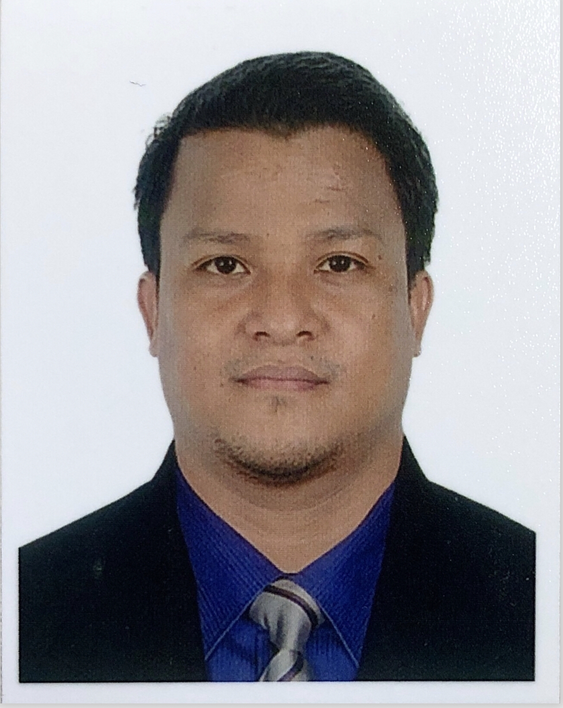**Jhonrel C. Acolicol**

Deira, Dubai UAE

Mob: +971552567983

jhonrelacolicol@gmail.com

**Career Objective**

To secure a position that will provide avenues for continues learning and improvement of my skills aside from optimizing personal and professional growth and harnessing ability in cultivating harmonious work relationship with other people.

**Working Experience**

**Prestige Perfume – Sales Associate**

Global Village Cambodia Pavilion Exhibitor , Dubai UAE

November 2020 – Up to present

* Meet and welcome customers
* Assisting and understanding the customer needs about the product and prices
* Ensuring high level of customer satisfaction
* Introduce them the best seller perfumes and test it to keep upselling
* Maintain general cleanliness, hygiene standards and visual display

**BrilliantMind Events – Server / Assistant**

Dubai, UAE

June 2019 – September 2020

* Welcoming the guest when they arrive
* Serving and assisting their needs
* Setup all the stuff that we used of the events and exhibitions
* Maintain the cleanliness and hygiene standards

**Qasr Al Khaleej Carpets and Furniture - Sales Associate/Cashier**

Global Village Iran Pavilion Exhibitor, Dubai UAE

November 2018 – April 2019

* Meet and welcome customers
* Assisting and understanding the customer needs about the product and prices
* Ensuring high level of customer satisfaction
* Issuing receipts and receiving payments in the cash register
* Maintain general cleanliness, hygiene standards and visual displays

**Chateau Blanc Patissier - Server/ Waiter**

Jumeirah Road, Umm Suqeim 2 Plot 959, Dubai UAE

June 2018 - September 2018

* Meet and greet customers and bring them to the table
* Present menus, and explain daily specials to customers to keep upselling
* Take orders and serve food and beverages to customers in dining establishments
* Maintain cleanliness in food service areas and throughout the food establishment

**Manoushe W Nos LLC - Refuel Fresh Juice Barista**

Dubai, UAE

August 2017 - April 2018

* Makes fresh juices and coffees in front of the customers
* Serving the customers of what they orders and bring to their tables
* Following “FIRST IN, FIRST OUT” basis in our daily stocks and fruits
* Maintain cleanliness inside and out of the kiosk

**PC Lane Marketing - Sales Coordinator**

Dipolog City, Philippines

February 2014 – Dec 2016

* Provides office services by implementing administrative systems, procedures, and policies; monitoring administrative projects
* We specialize on installing cctv cameras,IT products
* Manage of office papers, incoming and outgoing emails, receive calls, quotations, stock purchase through supplier

**Octagon Computer Superstore - Sales Coordinator/ IT Technician**

Dipolog City, Philippines

April 2007 – Dec 2013

* Provides office services by implementing administrative systems, procedures, and policies; monitoring administrative projects; maintaining suggestion program
* Supervised the daily needs of our store such as computer accessories, mobile phones, tablets, gadgets needed by our clients
* Diagnosing computer problem, hardware and software installation
* Manage of office papers, incoming and outgoing emails, receive calls, quotations

**Educational Background**

**Systems Technology Institute (STI-Dipolog) – Tertiary Education**

Dipolog City, Zamboanga Del Norte

Diploma in Information Technology Major in Computer Programming

2004-2006

**Skills and Qualifications**

* Hardware and Software Computer Installation
* Proficient in using computer applications (MS Word, Excel and PowerPoint)
* Excellent communication and writing skills
* Willing to learn and be trained

**Additional Information**

Birth Date: October 18, 1985

Age: 35 years old

Religion: Roman Catholic

Citizenship: Filipino