Curriculum Vita
Mrs. SOPHIA JAYAMERI. A 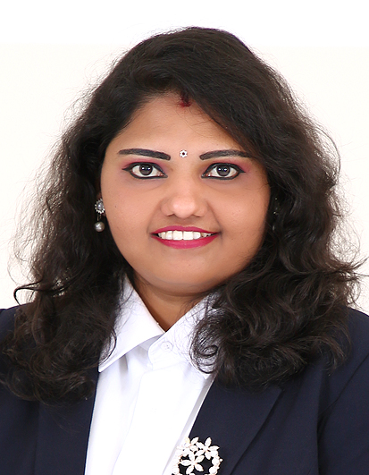
E-mail: sophijaya@gmail.com
Mobile: 050-3770126

Career Objective:
To be part of an educational institution which provides me with the opportunity to contribute my talent and professional skill for the growth and development of the children under my care?
Educational Qualifications
- Nursery Teacher Training Course (NTTC) at Bharat Sevak Samaj Vocational Education http://www.bssve.in/ (promoted by Government of India) 2003- 2004
- Industrial Training Institute (ITI) D/Civil with Auto cad course 2000 – 2002
- AISSE Grade 10 conducted by CBSE Kendriya Vidhyalaya Payyanur, Kerala (1999)
- Proficient in Ms office
Professional Experience 1 (India-Kerala)

- Worked as Primary Teacher for English, Maths and Science ( Grades 1- 4) at Gems English School ( CBSE) at Kasargode, Kerala from June 2009 to 2013
- Taught Draughtsman /civil at Noorul Hudha I.T.I Kasargode, Kerala 2010 to 2012

- Worked as a DRAUGHTSMAN in Code construction firm from 2002 to 2008

Professional Experience 2( U.A.E )

- Gulf Model School, Dubai – KG II-Class Teacher (April 2014 – April 2018)
- Gulf Indian High School, Dubai –as an Assistant Teacher (January 2019 to October 2019)

.

Personal Skills:
- Possess excellent written and spoken skills in English
- Able to work in a team and work under pressure
- Ability to handle work pressure
- Have a good communication skills
- Can do well in team work

Language Proficiency
Read and write : English and Hindi
Speak : English, Hindi, Malayalam, Tamil, Kannada

Personal Information

Nationality : Indian
Passport Number : L8096875
Date of Expiry : 23/03/2024
Visa Status : Husband Visa
Sex : Female
Marital Status : Married

Current Location :

SHARJAH

Reference:

Hero Sivan
Teacher Development Specialist
Ministry of Education, Dubai (0505300831)

Declaration
I hereby declare that all information furnished is true and correct to the best of my knowledge and belief.

A . Sophia Jayameri

