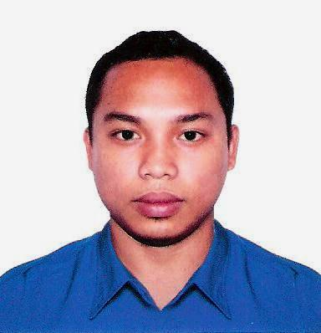

**Philip M. Andrade**

**Address:**  **Hamdan Street,Tourist club Area,Abu dhabi.Uae**

**Mobile#: +971553834109**

**Passport #: P0943980A**

**Visa Status: Cancelled Visa**

***Objectives:***

To work as a team in accordance with company objectives to gain employment in field and to further develop my skills that would fit my qualification.

**Position Desired:** **Welder Smaw, F-caw, Tig/Fabricator**

Personal Information:

Date of Birth : Feb. 13, 1991

Place of Birth: Batan, Aklan

Gender: Male

Age: 28 years Old

Civil Status: Single

Religion: Christian

Height: 5’1

Weight: 74kls.

Nationality: Filipino

***EDUCATIONAL ATTAINMENT***

**College**

*Course*: **Computer** **Programing** (2009-2011)

*School* : Dean Alberto Villarruz college

( Roxas, City Capiz )

**Vocational**

*Course*: **Automotive** (2007-2008)

*School*: Montfort Technical institute

(kalibo,Aklan)

**Secondary:**  Camanci National High School (2003-2007)

**Elementary:**  Camanci Elem school (1997-2003)

**TRAINING:**

Training center semacinternational training center Inc.

Training Course: Smaw NC 11

Training center: Pedrigal Welding Center Inc.

Training F-caw NC 11

**WORK EXPERINCE:**

Oct2019 To May 21 2020

Welder fabricator/ Tigwelder/Maintenance

Styro LLC. At musafa shabiya

Job discription:

**JOB DESCRIPTION:**

* Study and interpret Assembly instruction.
* Fabricate framework or Shells for machinery,oven, tanks,stacks and metal parts,building, bridges.
* Lessen to the direction/ instruction of supervisor.
* Fabricate and assemble metal products.
* Determine if all parts are present.
* Read and determine blue print and sketches.
* Assemble all part and materials.
* Position parts and Subassemblies’.
* Interpret measurements.
* Insured all parts are fitted and screwed properly.
* Alter the dimension to Fit specification
* Resolved assembly and product issues.
* Complete preventive maintenance.
* Troubleshoots the malfunction and performed refer if needed.
* Insured working area is clean and safe.
* Operate fabricating machines such as, rolls, shears and frame cutters.
* Report error in Product line.
* Complete quality control forms.
* Place orders for supplies.
* Participate in Product development.

**JAN 2016 TO july 2019** Welder fabricator

CATHAY INDUSTRIES&MILLS SUPPLY INC.

#42 San Francisco St. Karuhatan, Valenzuela City.

Tel#9217071/+63-99130234

**JOB DESCRIPTION**

**AUG 2014- OCT 2016 Fabricator/Welder**

**Ali Mohammed al sharany Factory**

**( Saudi Arabia,Khamis Mushayt K.S.A)**

**TEL#2331000**

**JOB DESCRIPTION:**

* Study and interpret Assembly instruction.
* Fabricate framework or Shells for machinery,oven, tanks,stacks and metal parts,building, bridges.
* Lessen to the direction/ instruction of supervisor.
* Fabricate and assemble metal products.
* Determine if all parts are present.
* Read and determine blue print and sketches.
* Assemble all part and materials.
* Position parts and Subassemblies’.
* Interpret measurements.
* Insured all parts are fitted and screwed properly.
* Alter the dimension to Fit specification
* Resolved assembly and product issues.
* Complete preventive maintenance.
* Troubleshoots the malfunction and performed refer if needed.
* Insured working area is clean and safe.
* Operate fabricating machines such as, rolls, shears and frame cutters.
* Report error in Product line.
* Complete quality control forms.
* Place orders for supplies.
* Participate in Product development.

**SEPT 2013-APRIL2014: Pull welder Smaw Fcaw**

**(Hanjin Ship Yard Subic bay Phil.)**

**Tel#( 045)4623142**

**JOB DISCRIPTION:**

* Read and interpret working plans and steel list for the job.
* Make steel bars or measure the required lengths by cutting them with both guidelines.
* Assemble the reinforcing bar or mesh by welding,wiring or clipping into predetermined location within the concrete.
* Fabricate steel reinforcement as beam flouting pads, or specials units.
* Join the Refabricated units together for large sections of high rise, or civil projects, and position the Reinforcement ready for concrete pours.
* Maintain good performance and other Duties assigned by Superior.

I Hereby certify that the above information is true and correct to the best of my knowledge and belief.

**Philip M. Andrade**

*Applicant Signature*