**CURRICULUM VITAE**

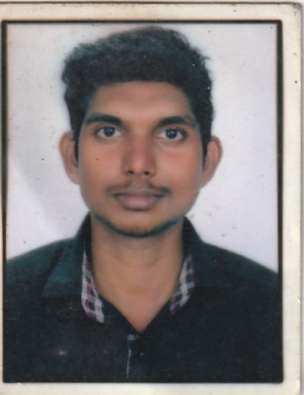

**VYSHNAV.S.L**

Mobile: +91 8943175061

Email: vyshnavsl736@gmail.com

**OBJECTIVE**

To work in challenging environments highly motivated and determined to succeed and enrich my skills as to attain a good position and contribute effectively to growth of the organization.

**EDUCATIONAL & TECHNICAL QUALIFICATION**

## Diploma (Computer)

## PLUS TWO (Humanitics)

## S S L C (SECONDARY SCHOOL LIVING CERTIFICATE)

**WORKING EXPERIENCE**

* Worked as Security Guard in Bhagavathy Agencies, Trivandrum from 01-04-2017 to 31-08-2019

**DRIVING LICENSE**

License No : 22/2208/2015

Date of Expiry : 13/05/2035

**SKILLS**

* Patrolling.
* Law Enforcement.
* Customer Service.
* Attention to Detail.
* Communication **Skills**.
* Surveillance.
* Written Communication

**PERSONAL PROFILE**

Father Name : Shaji Kumar

Date of Birth : 08/08/1994

Gender : Male

Religion : Hindu

Marital Status : Single

Nationality : Indian

Hobbies : Travelling, Reading

Languages Known : English, Hindi and Malayalam

**PASSPORT INFORMATION**

Passport Number :

Date of Issue :

Date of Expiry :

**DECLARATION**

I hereby declare that the information furnished above is true to the best of my knowledge.

Yours Sincerely,

**VYSHNAV.S.L**