CURRICULUM VITAE

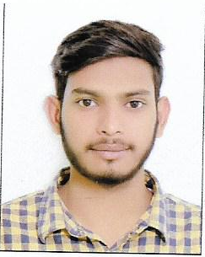
ARIF SERAJ
Male; Single; DOB: 15/01/1998
Phone: +918799377091

CAPABILITIES

Problem solving attitude - Good Intellectual abilities with Practical Sense.
Drive to learn and Achieve – Self-motivated, Patience, Energy, Determination & Good communication skills.

.

EDUCATION DETAILS

I have done high school with 1st division and the percentage is 64 %

SKILLS & ABILITIES:-

:-Good problems solving skills.
:-Descent interpersonal & communicational skills.
:-Willing to work in any environment.
:-Impressive leadership qualities
WORK EXPERIENCE
I have an experience 03 year experience for mobile repairing and software.
PERSONAL DETAILS

. Name : ARIF SERAJ
Father’s Name : Mr. SERAJ AHMAD
Mother’s Name : SHABNAM PARVEEN
Permanent Address : House no.203,Abdul Hakeem Katra Takiya , Azamgarh, U.P. – 276001.
Nationality : Indian
Language Known : English, Hindi, Urdu.
Hobbies : mobile software & hardware

DECLARATION

I solemnly declare that the above information is true and correct to the best of my knowledge. I understand that if any information given above is found false/incorrect, my candidate is liable to be rejected.

Date: ARIF SERAJ

