#### ***RESUME***

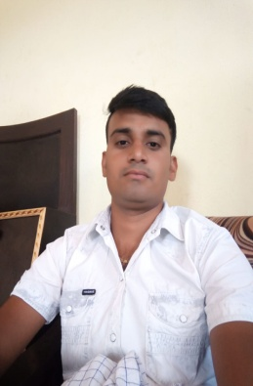**JAI SINGH**

Village Ruppur sarai, PO Sareli,

Tehsil Narnual and Distt. Mahendergarh

Mob. –8569867043

Email : jaisinghbhargarh@gmail.com

***Career Objective:***

* To work in a progressive and growth oriented organization that can give me better opportunities to utilize my present capabilities and enhance my knowledge base for future betterment of the organization as well as personal goals.

***Academic Qualifications:***

* 10thPassed with 50 % marks from HBSE Bhiwani.
* 12th Passed with 58 % marks from HBSE Bhiwani.
* DTT (Diploma in Teacher Training /Two year ) Red Cross Computer Center Nangal Choudhary

***Experience***

* 3 year computer software Teacher Training (Red cross computer center Ateli Mandi 123021)

## ***Skilp***

Good knowledge of Ms Office (Microsoft Word, Excel, Powerpoint) and Tally 9.0 & 7.2 ERP with Gst .

And Good knowledge of Html & C , C++.

***Languages Known:***

* Hindi & English

***Positive Traits:***

* Hard-working
* Sincere with a High level of integrity.
* Work effectively with diverse group of people.

***Personal Details:***

**Father’s Name : Sh. GOKAL CHAND**

**Date of Birth** : 18th FEB, 1995

**Gender** : Male

**Nationality** :Indian

**Marital status** : Married

**Date: ………….**

**Place : Ruppur Sarai (JAI SINGH)**