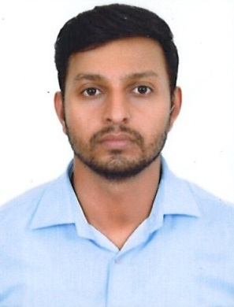 | Rijin Parambalath  Store manager at TECQ  7559846766  rijin.parambalath@gmail.com

ABOUT ME

- 6+ Years of UAE sales and marketing experience in companies like Touch mate & Huawei.
- A versatile and skilled sales/marketing professional with leadership qualities and excellent hands-on experience in developing and improving sales for wholesale and retail operations.
- An assertive professional with outstanding interpersonal, communications, negotiation and people management skills.
- Good Command over spoken and written English, Hindi & Malayalam.
- Remarkable knowledge of basic merchandising theories and practices.

QUALIFICATIONS
- Bachelor of Arts (BA) from University of Calicut - Kerala, India.
- Diploma in Fire & Safety Engineering.
- TECHNICAL SKILLS
- Hardware : System Assembling & Troubleshooting.
- Operating system : WIN 98, WIN XP, Windows VISTA, Windows 7,ANTROID
- Networking /protocols : Server 2003 administration, Server 2008

- EXPERIENCE
STORE MANAGER @ TECQ
landship mall , mavoor raod ,calicut.
FEB 2018 - at present

Sales supervisor @ Huawei Mobile
Dubai, UAE
Dec 2015 To Jan 2018
Job Duties and Responsibilities:
- Provides services to the customers from different locations, develop customer contacts, creates business opportunities, and executes other transactional activity for the company.
- Ensure and arrange stock of the Huawei products in the retail outlets.

Sales Promoter @ Touch mate
Abu Dhabi, UAE
April 2011 To November 2015
Job Duties and Responsibilities:
- Guide the customers for buying the products and explain them the features and specifications for the products.
- Giving correct details regarding the after sales service and ensure customer satisfaction.
ADDITIONAL INFORMATION
Personal Details:-
Date of Birth : 2nd February 1986
Marital Status : Married
Nationality : Indian

References:-

Available upon Request

The undersigned hereby certifies that all information given in this document is true, complete, and correct.

RIJIN PARAMBALATH

