CURRICULUM-VITAE

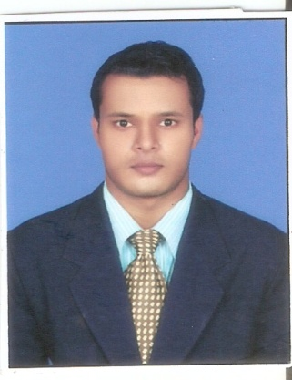

SHAIKH ASHIQUR RAHMAN ROOM NO. 25/12, Vivek Nagar
Ejipura
Bangalore-440030
Contact No – +918088991901
Email ID- ashiqurshaikh2017@gmail.com

CAREER OBJECTIVE

Seeking a deserving profile in the hospitality sector, where I can deliver my expertise and innovative hospitality skills.

WORKING EXPERIENCE:-

- I worked as a Senior Waiter at Hotel the Retreat Madh Island Malad, Mumbai. From 2009 to 2011

- I worked as a Senior Associate in F& B Service Department at Novotel Hotel by Accor group hotels Juhu beach Mumbai from Jan 2011 to Apr 2013.

- I worked as a asst waiter at ROYAL PRINCESS CRUISES from Dec 2013 to August 2015 Miami, Florida, United State Of America, USA

- I worked as a Butler in F & B Service Department at ITC MARATHA HOTEL MUMBAI 2015 to 2016.

- I worked as a Tour Executive in Karma Hospitality Groups Pvt Ltd from 2016 to 2018 In Benaulium Goa.

- I worked as asst Unit Manager in Alexis Hospital by Avon Hospitality Pvt ltd Nagpur 2018 to 2019 Feb.

- Presently working as a Asst Manager in Elior Hospitality Bangalore.

RESPONSIBLITIES

- Hiring, planning, executing and involving in multitude of activities.
- Look after food and safety
- Look after all operation on floor.
- .keeping the inventory of material, maintaining service quality continuously..
- Prepare monthly cheque request for suppliers and closing monthly accounts.
- Maintain reports of daily and monthly store purchases, issues and consumption

.
EDUCATION QUALIFICATION:-
Academic Qualification : 1.matriculated from the Orissa Board
2. +2 passed from the Orissa Board
Professional Qualification : Completed 3 Years Bachelor Degree in Tourism and
Hospitality Service from Biju Patnaik College of
Hotel management & catering under Utkal
University of culture Bhubaneswar, Orissa

TRAINING EXPOSURE:-

- I have done my industrial training in food & Beverages Services Department at Quality inn Rivera Choice Group of Hotels Ahmadabad, Gujarat India.(2005 - 2006)
- I have done 1 Years HOT Program in food & Beverages Services & Front Office at Lahari Resorts Hyderabad.(2007 – 2008)

PERSONAL PROFILE:-

Name : Shaikh Ashiqur Rahman
Father’s Name : Shaikh Jahangir Ali
Date of Birth : 20TH JAN 1987
Gender : Male
Marital Status : Single
Nationality : Indian
Religion : Muslim
Languages Known : English, Hindi, and Urdu & Oriya

PASSPORT DETAIL:-

PASSPORT NO-H8045747
DATE OF ISSUE-03/06/2010
DATE OF EXPIRY-02/06/2020
PLACE OF ISSUE-BHUBANESWAR (India)

STRENGTH:-
- Ability to absorb the extra bit of pressure whenever required
- Ability to cope with failures and learn from past mistakes.

DECLATION:-

I solemnly declared that the above information is true and correct to the best of my Knowledge and Belief.

Date:
Place: - Bangalore (SHAIKH ASHIQUR RAHAMAN)

