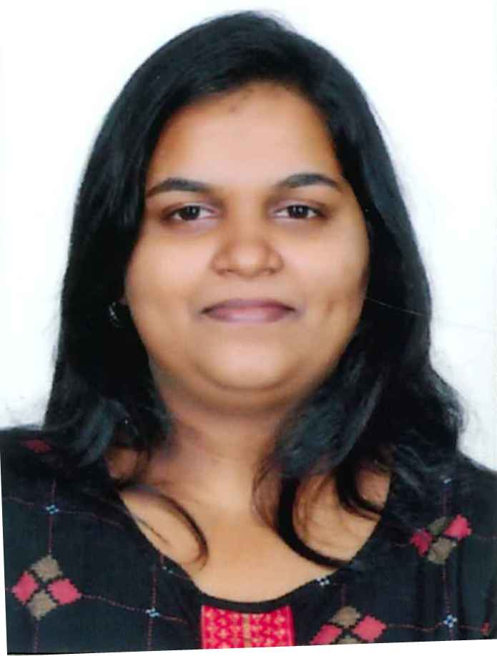
C.V

Mobile: 0566755026 , 0543589276
- Email : fenissia99@gmail.com

- OBJECTIVE:

To achieve a suitable position that will Commensurate to my qualifications and there impart substantial contribution to the company.

- PERSONAL INFORMATION :

- Name : SHELVI FENISSIA
- Date of birth : 11/08/1999
- Nationality : INDIAN
- Gender : Female
- Marital status : Married
- Address : Abu Dhabi – U.A.E

- EDUCATION CERTIFICATE:
- CA( CPT, IPCC) FROM LAKSHYA CA CAMPUS KANNUR
- XII FROM THE BOARD OF HIGHER SECONDARY EDUCATION PERALASSERY KANNUR KERALA
- XTH FROM KADAMBUR HIGH SCHOOL KADAMBUR

- CAPABLE TO DO

- BILLING
- FRONT OFFICE
- BACK OFFICE
- ACCOUNTANT
- FINANCE
- GOOD KNOWLEDGR IN OPERATING COMPUTERS AND FAMILIAR WITH ITS OPERATIONS
- CAPABLE TO MANAGE A TEAM
- SALES

LANGUAGE KNOWN:

- English( R,W,S)
- MALAYALAM(R,W,S)
- HINDI(R,W,S)
- TAMIL(S)

- EXPERIENCE:-
- I have computer experience
- I have1 year front office experience
- I have experience in accounting

- OTHER SKILLS:
- Ability to work.
- Ability to communicate with people.
- Ability to solve the problems.
- Co-operator with team work.
- Ability to work under any pressure.
- Very good in solving problems.
- Good in communication skills.

- Interactive and fast enough to learn new technologies and Languages.

DECLERATION

I HERE BY DECLARE THAT THE ABOVE MENTIONED INFORMATION IS CORRECT UP TO MU KNOWLEDGE AND I BEAR THE RESPONSIBILITY FOR THE CORRECTNESS OF THE ABOVE MENTIONED PARTICULARS.

