SHIFIN S
Date | 09-01-2020
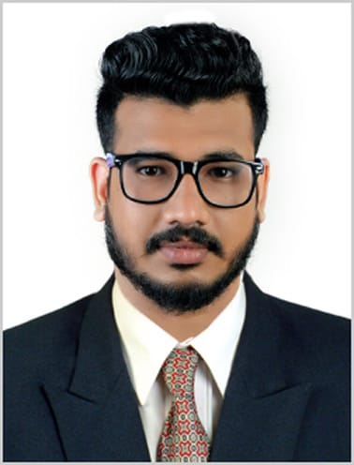 | ABU DHABI,  MUSAFFAH,  UAE.  Phone:+971545287546  Whatsapp :+971558363168  shifinoachira@gmail.com

Objective
To be the part of a growing and reputed organization, which provides ample opportunities for me to utilize my knowledge and skills thereby, contributing to the success of the organizatio thus leads to my personal growth.

profile

Father’s name : Shamsudheen Kunju

Date of birth : 28-08-1994

Gender : Male

Religion : Muslim

Nationality : Indian

Marital Status : Single

Blood Group : B+ve

Passport no : M4228618

Education
- Diploma in automobile engineering from NOORUL ISLAM POLYTECHNIC COLLEGE, PUNKARAI.(MARCH 2014)
- V.H.S.E with maintenance and repairs of automobiles as specification from KERALA STATE BOARD OF EXAMINATION with 70% marks. (MARCH 2012)
- SSLC from KERALA STATE BOARD OF EXAMINATION with 70% marks. (MARCH 2010)

experience

SALES
- One and half year experience in vehicle showroom.
- More than two year experience in sales and marketing in wholesale business in a TMT STEEL BAR company named(KAIRALI TMT) brand ambassador a film star MR.MOHANLAL.As me doing a district in-charge.
- Six month sales experience in electronics department on SHARAF DJ at MEGA MALL SHARJAH.

SWIMMING
- One year and seven month experience in UAE doing like a Professional Swimmer in MAREENA, JUMERAH, DAMAC (valued license) lifeguard.

SUPERVISING
- One year and four months experience in site supervising on a construction company named BHAGYA CONSTRUCTIONS.

DRIVING
- Expert in all type of vehicles can be drive like medium vehicle, heavy vehicle, earth mover vehicle’s like JCB, BOB CAT, SKID STEER etc.

SKILLS AND ABILITIES

PROJECTS DONE
- Air Assisted Hydraulic Brake System in Two Wheelers.
- RC Making with manufacturing products.

EXTRA CURRICULAR
- Badminton
- Skill in making new innovations and ideas
- Swimming
- Electronics Repairing

Communication

LANGUAGES Read Write Speak
- ENGLISH Yes Yes Yes
- HINDI Yes Yes Yes
- ARABIC Avg Avg Yes
- TAMIL Yes
- MALAYALAM Yes Yes Yes

declaration
I hereby declare that all the particulars given above are true and complete to the best of my knowledge and belief.

Place: Sharjah

SHIFIN S

