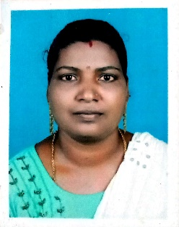**ANEESHA.A. V**

E mail id: aneesha.arjunan@gmail.com

Mobile No: 7025232088

Address: Abhishekam, Kanjiramvila Nellikkunnu

Mulloor P.O, 695521

______________________________________________________________________

**CAREER OBJECTIVE**

I am seeking opportunities to join a company that can help me in enhancing my skills, strengthening my knowledge, and realising my potential. I am willing to explore a wide variety of opportunities that can help me gain perspective.

**ACADEMIC QUALIFICATION**

* **SSLC, 2003, H S Balaramapuram**

**PROFESSIONAL SKILLS**

* Time management
* Typing speed
* Basic knowledge of computers
* Data entry
* Customer Support

**WORK EXPERIENCE**

* **Mobile Customer Care –** Worked to support mobile plan selection and recharging (2009 -2010)

**ADDITIONAL CERTIFICATION**

* **Domestic data entry operator, Adani skill development center**

**PERSONAL DETAILS**

Father’s name : Arjunan.S

Date of birth : 18 MAY 1988

Gender : Female

Nationality : Indian

Marital status : Married

Language : Malayalam

**DECLARATION**

I hereby declare that all the above information is true to the best of my knowledge and belief.

Place : Mulloor Signature

Date : 19/102023