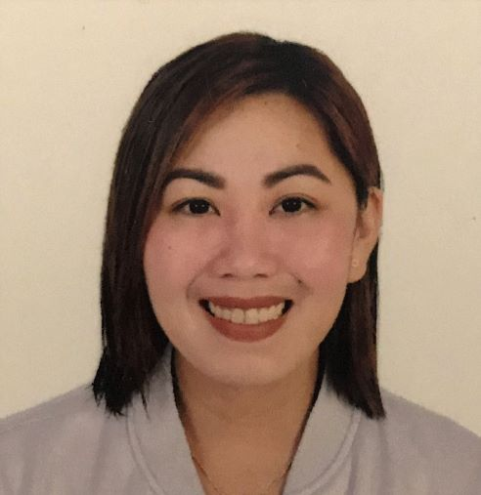

**ELLA MAY N. BALBIN**

**Address: Al Falah St. Abu Dhabi, UAE**

**Mobile: +971545012078**

**Email:** [**ellamaybalbin@yahoo.com.ph**](mailto:ellamaybalbin@yahoo.com.ph)

**OBJECTIVE:_________________________________________________**

**- To contribute my skills for the development of the company.**

**- To work in an institution where there is the long term opportunity to grow.**

**EDUCATION:________________________________________________**

**College : Colegio De San Juan De Letran**

**Bachelor of Arts in Broadcasting**

**2008-2012**

**High School : Espiritu Santo Parochial School**

**Elementary : St. Theresa’s College Quezon City**

**WORK EXPERIENCE_________________________________________**

**March 6, 2016 – June 18, 2020 Operation Team Member/Customer Service**

**ARAMEX**

Aramex Building, Muroor Road, Al Muroor, Abu Dhabi

Landmark: Opposite Bus Station, Near Red Crescent

Tel: +971 2 5551911

Fax: +971 4 8707744

* Deal directly with customers by telephone.
* Respond promptly to customer inquiries
* Handle and resolve customer complaints
* Obtain and evaluate all relevant information to handle product and service inquiries
* Provide pricing and delivery information
* Perform customer verifications
* Organize workflow to meet customer timeframes
* Direct requests and unresolved issues to the designated resource
* Manage customers' accounts
* Keep records of customer interactions and transactions
* Record details of inquiries, comments and complaints
* Record details of actions taken
* Manage administration
* Communicate and coordinate with internal departments
* Follow up on customer interactions
* Provide feedback on the efficiency of the customer service process

**August ’14- October ’15 Bancassurance Sales Executive**

**BPI- Philam Life Assurance Corporation**

15th floor Ayala Life-FGU Center

6811 Ayala Avenue Makati City

* Solicit new business, cross sell and up sell identified BPI- Philam products to the bank’s customer base.
* Establish, maintain and grow relationships with prospective and existing clientele; perform customer service and business conservation activities.
* Establish, maintain and grow relationships with the bank officers and staff in the branch as they are assigned to for the purposes of generating bancassurance leads and business.
* Handles activity reporting, planning and administration.
* Conducts market analysis activities, such as branch/client profiling and survey on competitor products.

**January ’13- February ‘14 Sales Associate**

**Security Bank Corporation**

Security Bank Centre 6776 Ayala Avenue

Makati City

* Responsible for acquiring of new accounts and growth of new solicited accounts.
* Identifies potential clients for various deposit, loan and investment products of the Bank.
* Conducts presentation and facilitates marketing activities to introduce the different products of the bank.
* Maintains strong business relationship with existing clients.

**June ’12-October ’12 Customer Service Representative**

**SPI Global, Inc**

PLDT NSOB, Espana Blvd.

Mayon, Quezon City

* Answer calls and respond to emails.
* Handles customer inquiries.
* Manage and resolve customer complaints.
* Provides customers with product and service information.
* Document all call information according to standard operating procedures.

**September ’07-February ’08 Recruitment Associate**

**TRG Philippines, Inc.**

8/F Hanston Bldg.

F. Ortigas Jr. Avenue

Ortigas Center Pasig City

* Screening of resumes.
* Conducts phone interviews.
* Schedule and organize interviews with suitable candidates
* Assist Recruitment Specialist in screening eligible candidates
* Participate at recruiting events when the manager cannot attend
* Keep records of candidate interviews and report them to recruitment managers

**PERSONAL BACKGROUND:____________________________________**

**Date of Birth: May 18, 1988**

**Height: 5’4**

**Civil Status: Single**

**CHARACTER REFERENCES:_____________________________________**

**Sirajudeen Abdulkader**

**+971 50 3600356**

**Operations Manager (ARAMEX)**

**Theodore John Magpantay**

**+63 927 314 3951**

**Business Area Manager (BPI-Philam life Assurance Corporation)**

**Monina Delarmente**

**+63 917 886 5634**

**Business Manager/Roll-Out Manager (Security Bank Corporation)**