**Name :** Suraj PK 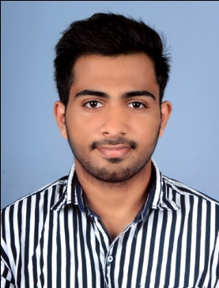

**Contact Number**: 7907067670

**E mail ID :**surajpk2@gmail.com

**Career Objective**

Motivated and accomplished outside Sales Representative attentive to details with outstanding follow-through. Proficient in building relationships, negotiating deals, and closing sales. Detail-oriented and innovative self-starter and congenial salesperson.

**Profile**

* Time management
* Self Sufficient
* Goal-Oriented
* Friendly and cheerful
* Approachable
* Client Relationship

**Professional Qualification**

**•** 1 year experience as cashier at **EVERYTHING SUPERMARKET**

• 1 year experience as sales man at **RELIANCE FRESH**

**Reliance Fresh, Kozhikode, Kerala, India**

Reliance Retail are committed to creating one of the world's most people-friendly, performance-driven, and process-efficient learning organization, where the best and the brightest work together to create a responsive, respectful and delightful work environment***.( https://relianceretail.com › reliance-fresh)***

**Designation:**Sales Executive

**Period:**Started from March 2018.

**Job Description:**

* Evaluate customers skills, needs and build productive long lasting relationships
* Meet personal and team sales targets
* “Get the sale” using various customer sales methods.

**Duties:**

To play a key role in increasing income and revenue by managing and negotiating with clients, generating leads, qualifying prospects and managing sales of products and services.

**Educational Qualifications**

|  |  |  |  |  |
| --- | --- | --- | --- | --- |
| Course | College / University/ school | Subject/ study details | Year of course  ( from – to ) | % of mark |
| Graduation | Calicut university | BA(English) | 2016-2019 |  |
| Plus Two | JDT Islam | Commerce | 2014 | 58% |
| SSLC | Kendriya Vidyalaya |  | 2012 | 58% |

**Technical Qualifications**

|  |  |  |  |  |
| --- | --- | --- | --- | --- |
| Course | College / University/ school / institution | Subject  Course details | Year of course  ( from – to ) | % of mark |
| ITI | CIESCO | Diesel Mechanic | 2015 | 60% |

**Languages**

* English
* Hindi
* Malayalam (Speak only)

**Personal details**

Name:Suraj P K

Fathers: Subash P K

Date of Birth: 12-04-1997

Sex:Male

Marital status:Single

Religion:Hindu (OBC)

Cast: Thiya

**Present Address / permanent:** Payngot Kandy kuttampoyil chalil malaparamba po.

Hobbies: Travelling

Long team goals: Learning a new set of skills and gaining experience in leadership and team-building.

**Declaration:**

I hereby declare that all the details above are true and correct to the best of my knowledge and belief.

**Place:** Calicut

**Date:** **Name and Signature**