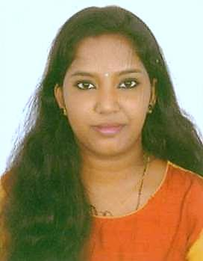
ANJANAMOL V G
Valiyavadakkedom (H) Kurumulloor (p o) Ettumanoor,
Kottayam, India 686632
Ph: 6363778267
kunjataanjana1996@gmail.com

PROFESSIONAL SUMMARY
Energetic and friendly receptionist with experience providing administrative support and customer service to clients and internal staff. Provides excellent customer service and builds relationships. Assists walk-in clients, schedules client appointments, answers phone lines, and helps clients with questions and issues.

EDUCATION

SSLC (10th )
St. Mary's Girls High School Athirumpuzha, Kottayam from March 2011

Plus Two
Govt. Higher Secondary School Kanakkari (Plus One & Plus Two) Kanakkari, Kottayam from March 2013

Diploma In Ayurveda Nursing and Panchakarma
Asramam Training Collage Vazhavara Idukki from July 2013 to July 2014

WORK HISTORY

December 2013 - November 2018 Sindhoor Ayurvedic Clinic - Banglore, India Designation :- Ayurveda Therapist

- Ayurvedic Medicine Production
- Ayurvedic treatments Training and teaching
- Full knowledge about all the Panchakarma
- Upakarma and Keraleeya traditional Ayurvedic procedures like vamanam, Virechana, Nasyam Raktamokshanam, vasthi etc.

December 2017 - Current
Keva Ayurveda Health Care Pvt. Ltd - Bangalore, India Designation:- Front Office Executive

- Established workflow processes, monitored daily productivity, and implemented modifications to improve overall performance of personnel.

- Requested, reviewed, processed and distributed status reports from various team members to executive management according to established workflow processes.
- Answered phone calls and handled booking
- Assisted co-workers and staff members with special tasks on daily basis.
- Successfully managed all Front Desk operations
- Checked in and checked out the patients ensuring accuracy of patient information as well as completeness of co-pays, charges, and insurance information.
- Offers Suggestions Regarding Treatments and patient Care
- Maintained cash receipts and completed all necessary paperwork to resolve any problems on the balance sheet.
- Maintained front office lobby area.

SKILLS
- Office Administration
- Scheduling
- Reliable and Punctual
- Excellent Communication Skill and Listening Skill
- Professionalism
- Efficiency

PERSONAL DETAILS
Date of Birth : 07-03-1996
Gender : Female
Father’s Name : George
Nationality : Indian
Passport No. : W7504595
Religion : Christian
Marital Status : Single
Languages Known : English, Hindi, Malayalam, Kannada, Tamil

DECLARATION
I hereby declare that the given particulars are true to the best of my knowledge and belief.

Place: Ettumanoor
Date: 11-05-2023 ANJANAMOL V G

