**HOSTESS/WAITRESS**

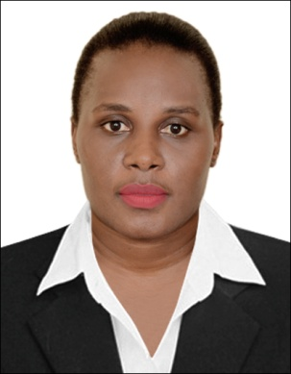**KUJAGUZA SYLVIA**

**PERSONAL DETAILS**

Nationality : Ugandan

Gender : Female

Passport No : B1465837

Marital Status : Single

E-mail :[bixler2008@yahoo.com](mailto:bixler2008@yahoo.com)

Mobile No : +971-581242119

+971-566725430

**OBJECTIVE**

As a highly motivated and creative individual,my career aspiration is to contribute the best of my services to this company. Utilize the knowledge, communication skills and efforts to work effectively in an organization. Be a responsible team player, making significant contributions to the success of the organization goals and strategic directions, As well as accuracy and confidentiality.

**PERSONAL SUMMARY**

A polite, well spoken and hard working person with experience of customer care and working in a busy environment. flexible team player,selfmotivated,professionally confident and friendly,willing to learn and train others.

**EDUCATIONAL ATTAINMENT**

The national council of Uganda YMCA, DIPLOMA ( CUSTOMER CARE /CATERING)

Uganda advanced certificate of education.(UACE)

Uganda certificate of education.(UCE)

**COMPUTER EXPERIENCE**

Microsoft word, Microsoft excel, Microsoft outlook.

**WORK EXPERIENCE**

**Company**: **Alkhaja Hospitality- DUBAI**

**Position**: **Receptionist / Hostess**

**Location: Dubai UAE**

**Duties:**

Welcoming Guests, directing them to their desired offices or departments of concern, receiving parcels from clients, Receiving phone calls, taking minutes in meeting and arranging schedules for meetings, Preparation for staff training, Assist with placement of orders, refunds, Solving customers complaints through telephone and physically.

**June 2015-July 2017**

**Company:** **Hotel Equatorial**

**Position:** **Waitress/ Hostess.**

**Location:** kampala-uganda

**Duties:**

Cheerfully greet guests, take them to their table and provide them with silverware and a menu. Monitoring the table rotation and make sure that each member of the waitress staff gets a fair amount of tables without giving them too many all at once. At the same time, I would arrange which servers to take extra tables when I get slammed with customers. Keeping track that tables are cleaned and available for new guests, answering phone calls, take reservations and in some cases take-out orders.

**STRENGTHS**

❖ Good communication skills

❖ Good Customer care

❖ Excellent attention to detail

❖ Ability to work independently and work in a team

❖ Able to respond quickly in emergency situation

Accuracy in data and confidentiality.

Strong team work.

Problem solving.

**REFERENCE :**

Provided upon request.