**RESUME**

**Subisha Suresh**

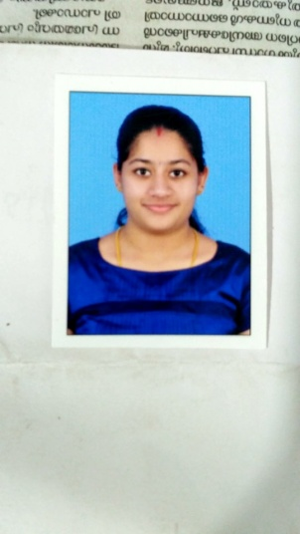

**Mobile: 9747299832**

**Email: subishasuresh26@gmail.com**

**Calicut, Kerala, India.**

**SUMMARY**

I have nearly 1.3 years of experience as HR Recruiter. I am looking for a career change and looking forward for opportunities in Administration domain.

Looking forward for an opportunity to work in an environment where I can utilize my knowledge and skills in contributing effectively to the success of the organization and enrich my personal and professional skills.

**WORK EXPERIENCE**

**Sure Events, Calicut**

**Resourcing Specialist**

**[March 2020- November 2020]**

**Responsibilities:**

* Sourcing and reaching out to qualified candidates for current open roles
* Screen resumes and job applications
* Conduct initial phone screens to create shortlists of qualified candidates
* Hands-on experience with the largest job sites like Naukri
* Good written and verbal communications skills
* Have handled candidates all over India mainly Bangalore, Delhi, Pune, Noida, Gurugaon, Mumbai, Hydrebad, Andra Pradesh, Chennai, Kochi, etc.
* Have handled both junior and senior level candidates for various opportunities based on the current openings.
* Have worked with MNCs like IQVIA, Silverline CRM, Symphony Retail AI, Systalent, World Bank etc that have counter parts working in US and UK.
* Used MS Outlook for mailings and prepared many types of trackers for respective clients on Microsoft Excel.

**What’sUp Solutions, Calicut**

**HR Executive**

**[December 2017- May 2018]**

**Responsibilities:**

* Calling companies to generate new business
* Getting vacancy details from employers
* Matching candidates to jobs to build a pool of potential applicants
* Screening and short listing candidates for employers to interview from Naukri, Indeed, OLX and other websites.
* Building relationships with employers and job seekers
* Meeting targets for vacancies filled and people placed
* Keeping records and negotiating fees
* Providing Offer Letters and other joining formalities to candidates.
* Used Microsoft Excel for preparing many data of candidates.

**Positions Handled**

IT Recruitment, Customer Relationships, Tele Calling, Client Retention and Office Administration.

**COMPUTER ACQUIATANCE**

* MS Outlook, Microsoft Word, Microsoft Excel, Microsoft PowerPoint.

**SKILLS AND ABILITIES**

* Attention to detail and a mature outlook on all tasks
* Punctual and hard working
* Consistently positive and personal commitment to achieve excellence
* Good communication skill

**EDUCATIONAL QUALIFICATION**

|  |  |  |  |  |
| --- | --- | --- | --- | --- |
| **Qualification** | **College/ Institution/School** | **board/university** | **Year of Passing** | **Percentage** |
| **MBA**  **(HR & MARKETING)** | IIKM B-SCHOOL, West Hill, Chungam, Calicut | Bharathiar University | 2017 | 72.2% |
| **BBA** | Providence Womens College, Malaparamba, Calicut | Calicut University | 2014 | 78.6% |
| **Plus Two** | Sharjah Indian School, Sharjah, U.A.E | Delhi University | 2012 | 74% |

**PROJECTS**

* A 45 days internship study on the effectiveness of employee welfare measures among the nursing staff at Starcare Hospital, Thondayade, Kozhikode.
* A 30 days study on the level of job stress among the employees at Sethus Export, Palazhy, Kozhikode.
* A 15 days study on the levels of customer satisfaction with respect to AKB TVS MOTORS, Kozhikode.

**HOBBIES**

* Trained in classical dance
* Art and Craft

**PERSONAL PROFILE**

**Date of Birth** : 26-10-1994

**Marital status**  : Married

**Husbands Name** : Rahul P .P

**Permanent Address** : Saphalyam, Pilasseri Paramba, Civil Station,

Kozhikode, Pin: 673020

**Present Address** : Palakkottuparambathe, Kurikkathoor,

Kunnamangalam(MIE), Kozhikode, Pin: 673571

**Languages known** : English, Malayalam, Hindi

**DECLARATION**

I hereby declare that all the above mentioned information is true to the best of my knowledge and belief.

Place: Kozhikode Subisha Suresh

Date :12-12-2020