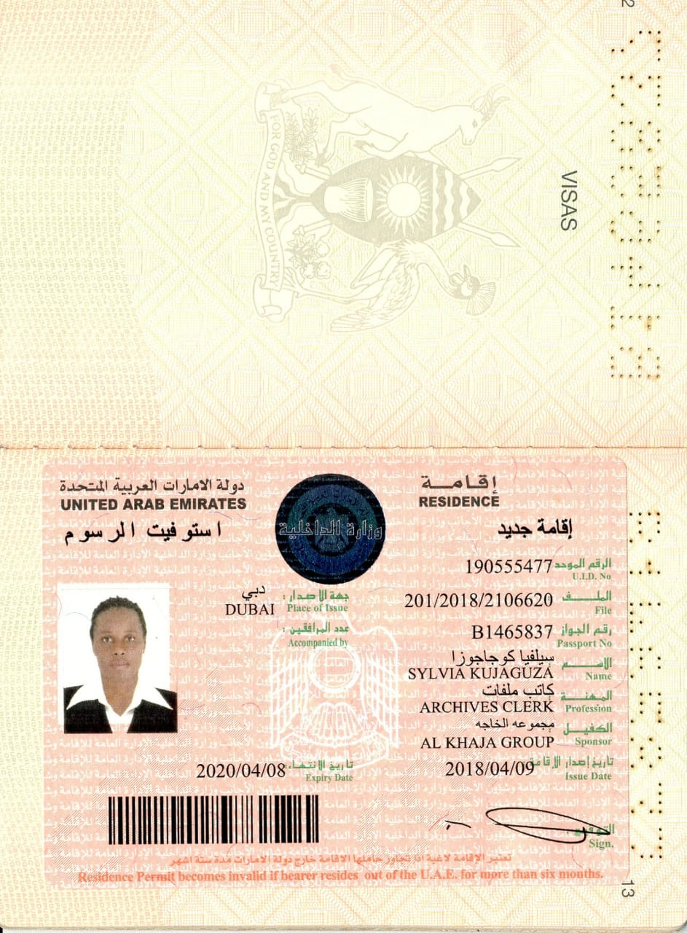  PERSONAL PROFILE:  I’m an enthusiastic, energetic and hardworking young lady with a successful and consistent track record of high returns for clients & business partners. I seek a suitable position with an exciting and expanding company.  PERSONALITY OVERVIEW:  • Good time management skills.  • Ability to finish tasks in a quick and efficient manner  • Possess excellent sales, marketing skill and highly disciplined with office manners.  • Excellent communication, Negotiation skills.  Hobbies  reading  working  touring  serving |  | SYLVIA KUJAGUZA  Sales/customer care-Dubai  Contact  PHONE:+917-581242119  EMAIL:Bixler2008@yahoo.com  Visa status: Cancelled  Nationality : Ugandan  Date of birth: 1981  EDUCATION  Uganda institute of bankers and financial services.(Accounting).  • Passed Uganda Advanced Certificate of Education  • Passed Uganda Certificate of Education  WORK EXPERIENCE  March 2018 to March 2020  Sales/customer care at First Lady Fashion and Design-DUBAI  Duties:  - Welcoming customers and children in a friendly manner.  - Excellent communication and care to customers and other members to maintain balance in all areas.  - Assist customers to find out products of their choice and size.  - Provided fast, friendly and accurate sales transactions at register.  - Maintained appearance of store.  - Stocked and organized shelves and stockroom  - Opened and closed the location in time and as needed.  - Answered the phone calls and transferred to respective locations.  - Keeping records of inventory and orders.  - Prepares supplies and materials necessary for day’s activities.  - Working as a team with my fellow employees to achieve the company targets and good customer services.  - Maintained a clean and very neat work area.  - Took care of many customer service issues both in person and over the phone.  - Distribute brochures and provide relevant information of the company to customers.  Jan 2015-Dec 2017  Sales associate at sisters Bridal  Duties:  - Greeted customers in a friendly and positive manner  - Recommending bridal gowns based on each customer's body type and personal taste.  - Informing customers about the range of styles, colors and cuts they can select from.  - Styling bridal looks with jewelry, veils, gloves and headpieces.  - Maintained an awareness of all promotions and advertisements  - Assisted with floor moves, merchandising, display maintenance  - Responsible for inventory control and aiding customers with locating merchandise  - Participated in year-end inventory and cycle counts  - Assisted with ringing up sales at register and bagging merchandise in  fast and friendly pace .  Language:  Expert in English.  References  [Available upon request.]

