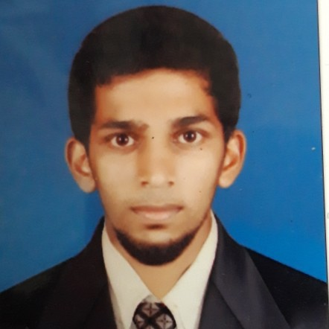
ZIYAD EK
Kerala, India
Mob: +91 9544337714, +91 7996618644

Application for Suitable post in Your Company

Dear Sir,

I would like to take this opportunity to express my interest to offer my services to your esteemed organization. I am Graduate in Master of business administration. I am currently looking for a long term career opportunity in your organization, corresponding to my qualifications.I am a loyal self-motivated, hardworking, and ambitious and have effective communication and interpersonal skills.

It is my belief that I have the ability to handle the designated tasks effectively and could contribute to your companys success. My detailed resume is enclosed for your perusal and I am confident that my qualification .

An interview would give me the chance to further prove my unique strengths. I would appreciate if an opportunity is given to prove my capability.

I hope to hear from you shortly.

Thank you for your time and consideration.

Sincerely

ZIYAD EK
CURRICULUM VITAE

ZIYAD EK
Email-Ziyadelikkunnummal@gmail.com

Mobile: +91 9544337714
Mobile: +91 7996618644

Career Objective

To make a positive impact in my field of activity leading to organization growth by creative application of my value based convictions and professional divinity by putting my all efforts in the work assigned to me in an organization where I can grow along with the organization

Software Exposure:

▪︎Tally .ERP 9
▪︎Peachtree
▪︎Quick Books and Word, Excel.

projects

▪︎A Study on effectiveness of online marketing with special reference to highline builders mavelikkara

▪︎A Study on Customer buying behaviour towards gold ornaments

Academic Qualification:

 | QUALIFICATION |  |  |  | INSTITUTE |  |  | YEAR |  |  |  |  | PERCENTAGE
 | MBA(MARKETING AND HR) |  |  |  | T john College Bangalore |  | 2019
 |  |  |  |  | Bangalore university
B.B.A(FINANCE) |  |  |  |  | Calicut university |  | 2016 |  |  |  |  | 58
 | Higher Secondary |  |  |  | Board of Higher Secondary |  | 2011 |  |  |  |  | 60%
 |  |  |  |  | Education, Kerala
 | School |  |  |  | SCERT.KERALA |  | 2011 |  |  |  |  | 58%
 | (Up to 10th)
 | Key strengths:

- Capability to hard work
- Presentation Skill
- Positive mindset

- High degree of self-motivation
- Team work Spirit

Personal Profile:

Date of Birth | : | 02-August 1994
Sex | : | Male
Nationality | : | Indian
Marital Status | : | UnMarried
Language known | : | English, Malayalam
Hobbies | : | Listening Music, Travelling.
Permanent Address | : | Elikkunnummal
 |  | Nittoor(post),Kakkattil(via)
 |  | Kozhikkode-673507, Kerala, India
Present Address | : | Elikkunnummal
Nittoor(post),Kakkattil(via)
Kozhikode-673507,Kerala, India
Religion | : | Islam
Declaration

All the given information above is true to the best of my knowledge.

Signature

Date :

ZIYAD EK

