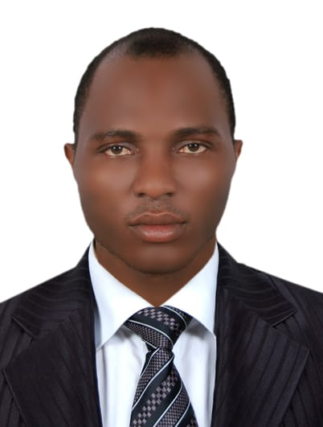 CURRICULUMVITAE

**Name :Frank Kelvin Nkemehule**

**Nationality : Nigeria**

**Email : franknkemehule@gmail.com**

**Mobile: +971566401261**

**Language : English**

**Address : Abu Dhabi**

**POSITION:REGISTERED NURSE**

**CAREER OBJECTIVES**

Patient-focused and empathetic registered nurse seeking a positionwithin any healthcare facility with good medical practice. Bringing with them experience, care and extensive knowledge to help improve the lives of their patients.

**SKILLS**

**Core Qualifications**

* Vast knowledge of industry standard nursing care policies andprocedures.
* Strong ability to respond to patients’ emotional and physicalneeds.
* Proficient in patient documentation and patientevaluations
* Impressive ability to work well in team settings.
* Ability to provide one-on-one patientcare.
* Very good time managementskills

**WORKINGEXPERIENCE**

**MEDIQ MEDICAL (TAMOUH) December 16 Till Date**

**DUTIES**

* **Checking vital signs**
* **Injecting vaccine to patient**
* **Accurate record of daily job done**

**PURE HEALTH CLINIC March 2020 till december 14**

DUTIES

* Conducting test swab test for CORONA virus
* listen to patients and analyze their physical and emotional needs
* assisting in registering patients for the Swab test

**HOMECARE NURSE| FAITH CLINIC,2015-2017**

**DUTIES**

* Provided patient with basic care such as, dressing, bathing, teeth brushing,and changing of beddings.
* Recorded vital signs blood pressure, pulse, temperature, respirations, and full body assessment.
* Administered medications, as prescribed by physician time and route including goral topical
* Recorded patient data/interventions into computer and report to management.
* Performed complete transfers from bed, chair, and wheel chair.
* Prepared meals, feed, and record intake and outcome.
* Provided social and physical interaction

**ACHIEVEMENTS**

* Referred disciplines including all therapies and social work as appropriate to patient and families as well as provided coordination of care and management of disciplines.
* Administered daily medications, analyzed daily intake of nutrition/fluids to determine if bolus supplementation/hydration is needed
* Maintained accurate and detailed patient records and charts.
* Provided comfort while developing and encouraging independence.
* **EDUCATIONAL QUALIFICATIONS**
* Diploma in Nursing and special needs education Lagos state university of science and technology
* High School Diploma