CURRICULUM VITAE
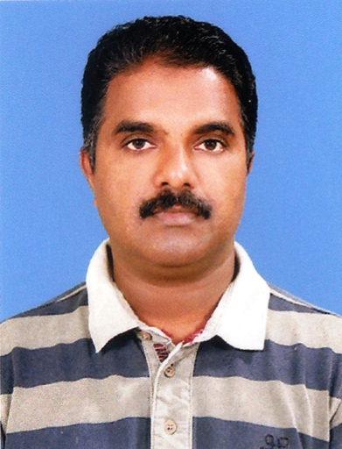
NASEER CM
Dildar House
Cheriyamangad
P.O. Koyilandy-673305
Calicut
Mobile: +919656931785
E-mail id: naseerqdy@gmail.com

Career Objective:

Seeking to establish a career with your progressive company, were my
experience can have an impact on the organization’s productivity, resulting
in my future career advantage. I am ambitious to work in a challenging and
competent environment, that can promote my abilities through achieving the
task in a most qualitative and accurate manner. With my ample working
experience; I am sure that i will overcome any challenges or problem
incurred. A defined goal to apply my skills and exposure to the industries to
the perpetually increasing field and thereby participate actively

Experience:

Worked as Accountant at Al Karama Group of Companies Sultanate of Oman from Nov.15 2006 to May 22, 2018.

Mode of Work and Job Profile

- pos sale posting

  - update daily sales and purchases department wise
  - invoice checking and posting
  - GRV checking and posting
  - selling price updating with proportional cost
  - make relevant debit/credit notes
  - inform the sales report to MD
  - inform the monthly sales and purchase status to GM
  - invoices and other documents filing
  - guide the purchaser to control the purchase as per the
daily status of cash flowing.

- cheque preparation

  - checks the payment aging report
  - recheck the invoices total figure
  - prepare the month wise aging invoice for payment
  - deduct the yearly debit notes & secondary display
  - making payment vouchers after the approval of GM
  - printing the cheques

- bank reconciliation

  - daily verification of the bank statement with system ledger,
and solve the discrepancies if any, with the consent of related bank.
  - updating the swapping card account frequently.
  - Dispatch of cheques to the suppliers according to the availability of fund in bank

- LPO

  - Making Lpo’s as per the Purchaser
  - After approval from Head office dispatching it to supplies

- Other activities

  - Attend and assist the front office at the peak hours.
  - Co-ordinate the staff in their day today affairs.
  - Monitoring the branch wise sales and purchase
  - More over doing all the office related work within time bound.

Future Objective:

To broaden my career horizons, based on the extensive experience gained
in various areas of business and Information Technology, I am actively
seeking a position where I can realize my complete potential in a global
business environment.

Educational Qualification:-

• Secondary School Leaving Certificate Examination from Govt Moppila
Higher Secondary School, Koyilandy Calicut
• Pree degree at Govt Arts & Science College Calicut
• Bachlor Degree from Govt.Arts & Science College Calicut, under University of Calicut
Diploma in computer application at Infotech computer Accademy Koyilandy
English type writing lower grade pass from technical education department
Govt. of Kerala.

Computer Skills:
• Microsoft Word, Microsoft Excel, Diploma in computer applications
Personal Highlights:
• Has good communication and interpersonal skills.
• Willing to learn and be trained to attain a high level of being.
• Willing to work in a multicultural environment.
• Young, energetic, active and is able to work under pressure.
• Has good moral character.

Personal Information:

Full Name : Naseer C.M
Father’s name Abdullah.
Nationality : India
Martial Status Married
Date of birth : 02-04-1971
Languages Known : English, Malayalam Hindi and Arabic (fluent in speaking and writing)

Passport Details:

Passport No : M5983050
Date of Issue : 07-04-2015
Date of Expiry : 06-04-2025
Place of Issue Muscat, Sultanate of oman

Declaration:

I hereby declare that all the statement made in this application is correct to
the best of my knowledge. An interview with convenient time and date shall enable me to substantiate my achievements.

Naseer C.M.
Dildar House
P.O. Koyilandy
Kozhikode (dt)
Kerala 673305 Mob: +91 9656931785

