**mohammed irshad**

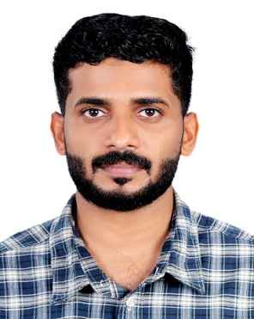

**Contact Address:**

Mob: **+91 9539188488**

Email:[atirshad@gmail.com](mailto:atirshad@gmail.com)

Oorakam melmuri-676519

Puthanpeedika, vengara

Malappuram, kerala

**CAREER OBJECTIVE**

To work with an organization that provides ample opportunity for my career growth so that I can contribute my best for the growth of the organization and myself.

**educational qualification**

|  |  |  |  |
| --- | --- | --- | --- |
| **EXAMINATION** | **SUBJUCT** | **BOARD/UNIVERSITY** |  |
| B.com |  | Calicut University |  |
| Higher Secondary | SCIENCE | Dept. of general education kerala |  |

**Technical Skills**

* Strong knowledge in various ERPs like i-trade, markup, D-mark
* Work experience in the customized ERP of TAJ AL FALAJ TRADING.LLC
* Knowledge and work experience in **MS Office and Excel**

**Work Experience**

*Organization* ***: METROHOME HYPERMARKET,*** *Kannur - India*

*Tenure : Jan 2013 to Oct 2015*

*Designation :* ***Accounts Asst. & Data Entry***

*Organization* ***: TAJ AL FALAJ TRADING LLC.,*** *Sohar-Oman*

*Tenure : Nov* 2015– Dec 2017

*Designation :* ***Inventory Incharge***

*Organization* ***: METRO HYPER POINT Pvt. Ltd., Kannur*** *-India*

*Tenure : Jan* 2018 –…………

*Designation :* ***IT Dept. & Purchase Co-ordinator***

***PROFESSIONAL PROFILE***

* Excellent team player and well organized.
* Good communication skills.
* Agile learner: adapt quickly to different situations, technologies, people and environment.
* Goal oriented, self-disciplined, dedicated and a smart worker.

**Personal Details**

Date of Birth : 13 November 1991

Place of Birth : Kerala, India

Nationality : Indian

Marital status : Married

Gender : Male

Religion : Muslim

Languages known : English, Malayalam, Arabic, Hindi

**Declaration**

I hereby declare that all the statements made in the above Curriculum Vitae are correct to the best of my knowledge and belief.

**MOHAMED IRSHAD**