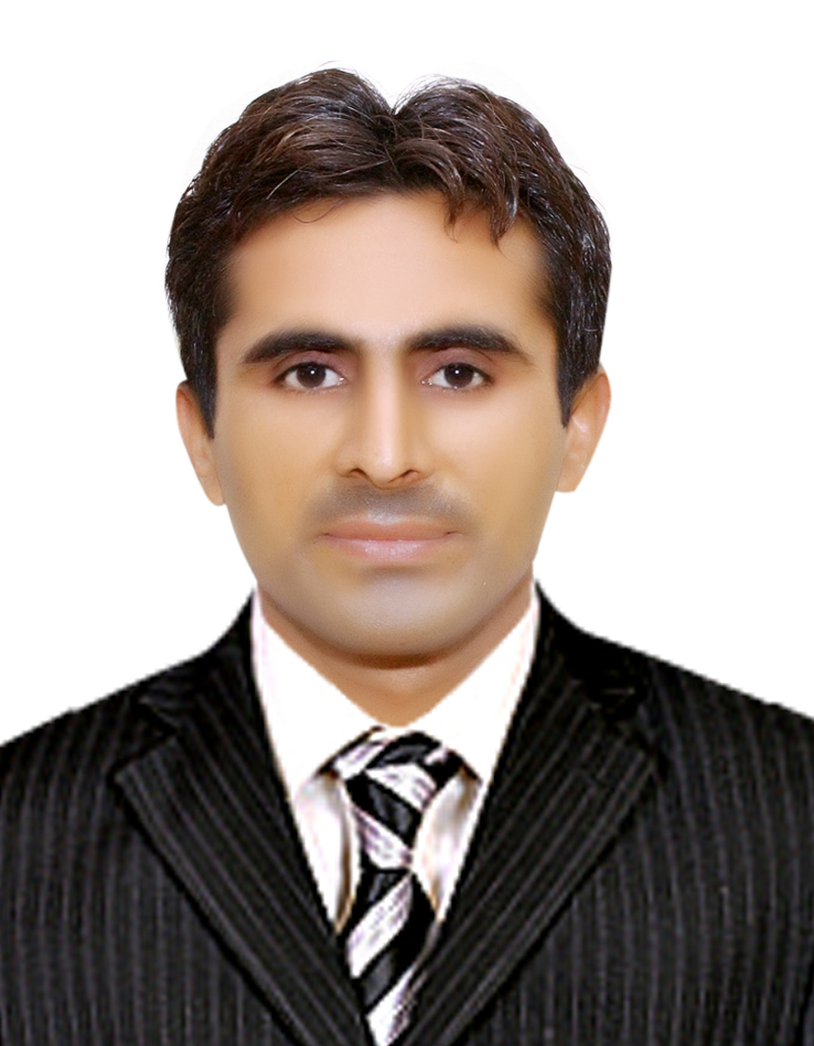
CURRICULUM VITAE
IKRAMULLAH
Add:- Rahmat Pur Oil Depo Larkana.
Email:-Ikramullah3@gmail.com
Facebook Link: https://www.facebook.com/ikramullah.khuhawar
Mobile#: +92302-3470723/+923058433002
OBJECTIVE
To seek a challenging position in an organization with an aim to contribute positively towards attainment of its objective to the vest of my knowledge
Having abilities, skills to serve honesty, integrity and dilig6ence with a firm belief that an entity’s growth and success would be my own.

PERSONAL INFORMATION
- Father’s Name : RANJHAN-KHUHAWAR
- Surname : KHUHAWAR
- Date of Birth : 12/06/1988
- C.N.I.C No : 43202-5258842-3
- DOMICILE : LARKANA-SINDH
- Nationality : Pakistani
- Religion : Islam
- Marital Status : MARRIED
- Passport No : CA2748422
- License No : 43202-5258842-3#822

ACADEMIC QUALIFICATION

Degree | Passing Year | Grade / Division |  | Board / University
Matriculation | 2004 | Grade “D” |  | B.I.S.E LARKANA
INTERMEDIATE | 2006 | GRADE “C” |  | B.I.S.E LARKANA
Bachelor in BSC | 2009 |  | 2nd CLASS | SHAH ABDUL LATIF UNIVARSITY
DIT-COMPUTER | 2009 |  | = | Classic Computer Science Larkana

EXPERIENCE
- 3 Years ‘experience at Asia Hotel & Restaurant Station Road Larkana as a Rooms Cleaning Supervisor from (March, 2011 to November, 2013).
- 2 Years’ experience at Asia Hotel & Restaurant Station Road Larkana as a Bike Food Delivery Boy from (2009 to 2011).
- 2 Month’s experience at Holiday International Hotel Sharjah UAE as a Banquet from
(January, 2011 to March, 2011).
- 6 Years’ experience at SZABIST College Larkana as a Administrative Assistant from (October, 2015 to till date September, 2021).
HOBBIES
- Reading Newspapers & Books
- Watching informative Programs
LANGUAGES
- English, Urdu , Sindhi

