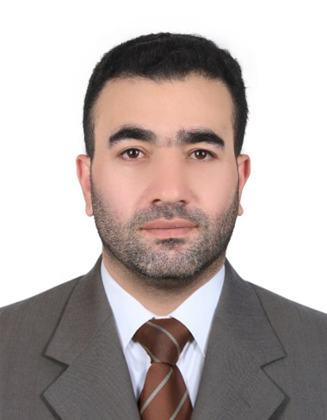

ISLAM MOHAMMAD ALKASJI

Mob: +971545430755

kasajiislam@gmail.com

PERSONAL INFORMATION:

Nationality: Jordanian

Gender: Male

Date of Birth: February 4, 1985

Residence: UAE

Visa Status: Own Visa – Sponsored
Driver Licensed: 06 November 2026

Objective:

To acquire a suitable position that will give me an opportunity to enhance and impart the knowledge and experience I have gained in the field of business development.

Willing to join a new field and deliver my capabilities to do work in accordance with the company standard and principles, to obtain new knowledge, and learn experience essential for my career growth in every responsibilities I could possibly handle.

Career Experience:

- GLOBAL LINK CORPORATE SERVICES LLC DUBAI
Public Relation Officer (P.R.O) – (January 2021 – July 2021)

Job Profile:

- In charge for processing visas such as employment and residence
- Organize and assist clients to their appointments in processing their medical test and emirates ID
- Process documents that needs to be attested by specific embassies and MOFA
- Managing of different companies‘ accounts

SPORT FOR ALL GENERAL TRADING LLC Dubai , UAE

Public Relation Officer (P.R.O) - (July 2013 to March 2020 )

Job Profile:

- Manage to process MOL and Immigration transactions for all employees
- In charge in processing of New Employment Visa, Residence Visa, Issuing emirates ID, Visa renewal, labour contract and labour cards.
- To monitor the regular updates on all MOL and Immigration processes standards and regulations.
- Organize and manage the Trade Licenses issuance and renewal on timely basis.
- Cancel the visa of the employee as it is required in labor & immigration department.
- Update all the records of the staff in order to renew their visa, labor card & health insurance.
- Renew & update the license of the company.

Handle collection of all the cheques and payments

- FASAL GLOBAL GENERAL CONTRACTING LLC Dubai , UAE
Admin Executive/Public Relation Officer (P.R.O) - (Nov. 2011 to June 2013)

Job Profile:

- In charge on administration department and personnel functions such as recruitment, records and documentation, employee relation, benefits and compensation, general affairs and services, and other related facets of human resources.
- Process the visas of all the employees such as employment visa, tourist visa, & mission visa and other related documents in labor & immigration department.
- Cancel the visa of the employee as it is required in labor & immigration department.
- Update all the records of the staff in order to renew their visa, labor card & health insurance.

Renew & update the license of the company.

SPECIALIZED TECHNICAL EQUIPMENT – STE Abu Dhabi,UAE

Sales Executive (March 2011 to November 2011)

Job Profile:

Maintain and develop good relationship through personal contact or meetings or via telephone etc.

Acts as a bridge between the company and its current market and future markets.

Display efficiency in gathering market and customer’s info to enable negotiations regarding variations in prices, delivery, and customers specifications.

Help management in forthcoming products and discuss on special promotions.

Records sales and order information and report the same to the sales department.

Provide accurate feedback on future buying trends to their respective employers.

Jordan Universal Wood Industries Co. Ltd. ( Jorsal & Crystal Amman,Jordan)

Administrative Secretary - (June 2005 – March 2010)

Job Profile:

Produce documents and spreadsheets, use specific software and correspond electronically.

Schedule departmental meetings. Set manager’s personal appointments.

Greet all guests and customers in a courteous and professional manner. Answer basic questions about the nature of the business and provide general company information.

Filing documents, maintaining employee records, placing orders and organizing office supplies

Education:

Al- Zaytoonah Private University of Jordan
Management Information System – Bachelor degree Graduated (August 2010)

Languages:
- Arabic - Native
- Good command of English language (reading, writing, and speaking)

Other Skills:

Computer literate

Have a driver’s license
- Handles high pressure situations
- Meets deadline and reliable
- Have an effective communication and decision making skills and ability to do multitask.
- Easy to adapt and willing to accept new knowledges or ideas
- Have own initiative and can perform a variety of duties

