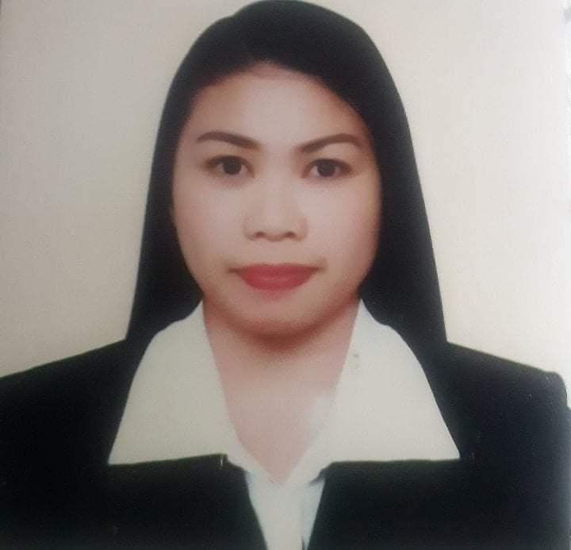
MELINDA AVILA SANTIAGO

Address: International City, Dubai, U.A.E.

Mobile : +971521098779
Email: mhelsantiago2845.ms@gmail.com

Objectives:

To seek a professional career and able to contribute on achieving company’s objective by delivering quality work and commitment on adding value by enhancing my skills and capabilities, through maximizing of my potentials based on my learning experiences and abilities.

Work Experience:

Selling Clerk and Innovation Clerk Savemore Supermarket
Quezon Province, Philippines
October, 2019 to March, 2020
DUTIES AND RESPONSIBILITIES

- Preparing the promotion price, new item price.
- Product new updated barcode.
- Top items list to be given to incharge selling clerk.
- Checking Incoming product and incode.
- Managing the all product or item for disposal or returning to their correct vendor.
- Incoding new requesting product or item.

Receptionist/ Manicurist Xiao Xiao Ladies Salon, Dubai (UAE)
May 15, 2017 to July 27,2019

DUTIES AND RESPONSIBILITIES

- Insuring the cleanliness of the work place
- Answering the calls and entertains the inquiry of the customer.
- Given best efforts with positive attitude for customer satisfaction by good service and caring of customer needs.
- Handling customer complaints.

Waitress Jiangnam Private Kitchen in Samaya Hotel
September, 2016 to December,2016

DUTIES AND RESPONSIBILITIES

- Greet the customer, assist them to the table, present the menu and explain the daily special and give recommendations.
- Taking food and beverage orders.
- Deliver the correct food and insuring the good quality of food.
- Clean the table areas, refill condiments roll silverware and stock service area.

Room Attendant Crown Plaza Hotel

Deira, Dubai(UAE)
March 17, 2015 to July 18,2016

DUTIES AND RESPONSIBILITIES

- Log in and Log out of master key.
- Preparing the trolley and vacuum.
- Cleaning of guest room/ bathroom/ hallways/ lobbies/ corridors/ stairways/ elevators.
- Replenish the supplies.
- Report the maintenance and unnecessary things.
- Purchase or order the amenities.

Production Operator PKI Philippines Kyoritsu Inc

April 2011 to September 2013

DUTIES AND RESPONSIBILITIES

- Inspect the area and allocated machine.
- Read the drawing.
- Ensure the equipment are maintained and in good condition.
- Work under the guidance of supervisor to perform and complete the assigned duties.
- Follow the safety procedures and company policies.
- Identify and report unsafe operation to team leader or supervisor immediately.
- Clean the area after finish the operation. Leave o time for security purpose.

Service Crew/ Waitress Kamaya Sa Palaisdaan

Philippines

January 2010 to April 2011

DUTIES AND RESPONSIBILITIES

- Greet the customer, assist them to the table, present the menu and explain the daily special and give recommendations.
- Taking food and beverage orders.
- Deliver the correct food and insuring the good quality of food.
- Clean the table areas, refill condiments roll silverware and stock service area.

Trainee of Reception Chambermaid

March 2009 to December 2009

DUTIES AND RESPONSIBILITIES

- Log in and Log out of master key.
- Preparing the trolley and vacuum.
- Cleaning of guest room/ bathroom/ hallways/ lobbies/ corridors/ stairways/ elevators.
- Replenish the supplies.
- Report the maintenance and unnecessary things.
- Purchase or order the amenities

Sales Clerk Anita Souvenir Shop

March 2008 to March 2009

DUTIES AND RESPONSIBILITIES

- Opening Setup / Closing Setup.
- Responsible for cash register.
- Stockings and quantity of sales.
- Customer Services
- Cleaning
- Inventory

Receptionist Com Secretary Blue Sapphir

( All Around) April 2007 to May 2008

DUTIES AND RESPONSIBILITIES

- Insuring the cleanliness of the work place.
- Insuring the complete and correct schedule of the delivery.
- Keeping the stocks and equipment in good condition.
- Answering the calls and entertains the inquiry of the customer.
- Arranging the delivery bills and credit account of the customer.
- Handling the sales and expenses of the company.
- Purchase the supplies.
- Scheduling the payment of suppliers and bills of the company.
- Depositing the money.
- Incode the details of the delivery and income.
- Preparing the next day schedule of delivery.
- Preparing the schedule of the staff and allocate to their position.
- Checking for the attendance and log out, log in of the staff.
- Managing the salary and insurance benefits of all staff.
- Report to Manager/ Owner.

STRENGTH:
- Comfortable and adaptable to work in all the conditions.
- Self confident, optimistic, sincere and reliable to take up responsibilities.
- Hard working and eagerly accepts and adapts the challenges and situation

EDUCATION BACKGROUND

College St. Mary’s Angels College of Pampnga Inc.
Philippines
Office Administration / undergrad

Secondary Luis Palad National High School
Philippines
2002-2006

Primary Dapdap Integrated School Philippines
1996-2002

Personal Information:

Date of Birth : May 2nd, 1990
Gender : Female
Religion : Roman Catholic
Nationality : Philippines
Status : Single
Languages : English and Filipino

Declaration:

I hereby certify that the above information is true and correct to the best of my knowledge and belief.

MELINDA AVILA SANTIAGO

