ANOOB.S.  JC.50/E, JC-BLOCK, HARI NAGAR – 110064  NEW DELHI  Tel.: +919711438117 (M)  E-mail: s.anoob@yahoo.com | 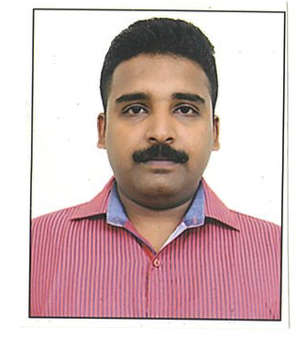
Objective:
My long term objective is to become an essential member of the core management team of a reputed organisation and to find challenging and creative position that enables to use my experience and knowledge.

Experience:
- Worked with M/s. GLOBAL EXCHANGE (RNS) -GURGAON, as a HR Executive Cum Computer Operator from April 2005 to March 2010.

- Worked with M/s. Robinson’s Sports Pvt. Ltd. Naraina as Store Keeper cum Office Assistant from April 2010 to September 2013

- Presently working with M/s.Scenario India. Greater kailash-2, New Delhi as a HR Executive cum Computer Operator since October 2013.
- Duties included: Devising and maintaining office systems to deal efficiently with paper flow, organizing and storing paperwork, documents and computer-based information, Making of Salary and Overtime, Vouchers, Cash Handling, Distribution of Salary and maintaining the all records of Employees Provident Fund & Employees State Insurance.
- Provided wide range of administrative and clerical duties for various levels of the Fidelity Management team.
- Provided administrative & accounting support to the management staff members.

Qualifications:
- Passed V.H.S.E from Board of Higher Secondary, Kerala.
- Computer Operator & Programming Assistant from NCVT, Govt. of India in July 2004.
- Working knowledge of in MS Excel, MS Word & Internet.

Key Skills and Competencies:
- Motivated Personal Assistant with demonstrated proficiency in listening to clients' needs and formulating the tactical action plan to achieve results.
- Able to maintain a professional and positive demeanour, regardless of the situation.
- Proven ability to take initiative in completing projects with exceptional quality and detail.
- Very energetic, extremely positive individual with excellent customer relations and decision-making skills.
- Highly involved in community events.
- Perseverance to achieve desired results

Personal Details:
Date of Birth : 21st.May.1986.
Nationality : Indian.
Marital Status :Married.
Joining Date : One month.
Passport No :S2461273
Languages :English, Hindi, Malayalam and Tamil.

Reference:
Reference will be provided on request.

Declaration:
I hereby declare that the information given above is true to the best of my knowledge and belief.
ANOOB.S.

