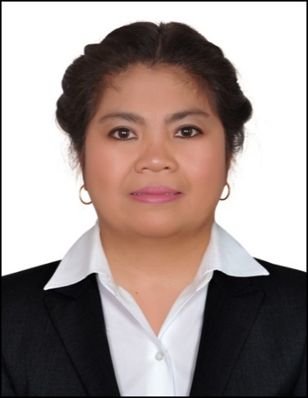Erlinda V. Comendador

Mobile: +97150-2247309

E-mail Add: ehrle_comendador@yahoo.com

Address: Dubai, UAE

(With 28 years of experience in Accounting Industry)

**PROFEESIONAL SUMMARY:**

Focused Account Personnel with years of experience. Adept at writing detailed reports and budgets as well as, completing detailed financial analysis. Detail – oriented with extensive knowledge of cash and record maintenance and comprehensive account reconciliations.

**SUMMARY OF QUALIFICATIONS:**

* Examined financial statements to ensure that they are accurate and comply with rules and regulations.
* Inspects account books and accounting systems for efficiency and use of accepted procedures.
* Assess financial operations and make best-practices recommendations to the management.
* Suggests successful ways to reduce costs, enhanced revenues and improveprofits.

**PROFESSIONAL SKILLS:**

* Knowledgeable in Internet Research and Windows Application software (MS Office: Word, Excel, Outlook, and PowerPoint)
* Knowledgeable in accounting software (x1601 – for travel agency, ACCPAC, Platinum, Peachtree, QuickBooks, Jobber for maintenance and cleaning jobs).
* Knowledgeable in booking software like Galileo and VRS
* Good in Customer Service Relations (Telemarketing, Emails and PR)

**DUTIES AND RESPONSIBILITIES HANDLED:**

* Reviewed budgets including capital appropriations and operating budgets and communicated findings to the senior management.
* Methodically reviewed documents and accounts for discrepancies and resolved variances.
* Reconciled balance sheets and stream-lined best practices for balance sheets processes.
* Prepared monthly financial report and income statement.
* Monitored the cost against sales of the company.
* In charged of purchasing order and follow-up the supplier for the delivery.
* Assisted in employees processing of visa, occupational health card, and health card insurance.
* Released all the payment for the promoters and any payment in the office.
* Acted as admin assistant for any office requirement like supplies, salary certificate and employee’s record.
* In charged for the overall accounting report.
* Assisted in phone reception for executive and administrative departments.
* Received payment for various transaction made by the counter staff.
* Prepared the deposit slips for the money collected for the day.
* Checked all the ticket coupons for sales report and entry made by the counter staff.
* Prepared payment for ticket cash purchases and refund ticket of the client.
* Purchased Inventory ticket stocks and Cash Disbursement Book.
* Petty Cash Custodian.
* Part time secretary to answer the various incoming calls and other inquiries.
* Assisted in preparing sponsor letter.
* Transmittal of various documents for loan approval.
* Arranged necessary deliveries of merchandise ordered.
* Updating lapsed schedule for company properties and equipment.
* Posting of books summaries to working trial balance.
* Debit/Credit memo against account receivable-trade.
* Payroll, various government taxes remittances and other local security system contributions.
* Handled Adjustment entries, Monthly sales commission, Advertising and Promotion expenses.
* Checked sales invoice against their corresponding purchase order and its computation.

**DETAILED WORK EXPERIENCES:**

**Accountant Top Kit Technical Services LLC Dubai, UAE**

May 9, 2019-present

**Finance Manager/HR Executive Cuisinero Uno Restaurant LLC**

September 23, 2016-February 27, 2019

**Accounts & Admin Officer FLC Marketing Consultancy Dubai**

Feb.23, 2012-November 16, 2016

Accounts Assistant Qeshm Travels & Tourism Dubai, UAE

November 2, 2007-October 8, 2011

Accountant Long Island Travels

March 8, 2006-November 2, 2007

Accounts Assistant cum secretary OMS International INC Phil’s

November 16, 1998-October 30, 2005

Accounts Assistant FCG Ind., Inc

July 6, 1998-November 15, 1998

Accountant Abenson Sales Corporation Phil’s

April 27, 1996-June 27, 1998

Accountant International Brands Regency Phil’s

August 23, 1993-March 15, 1996

**EDUCATIONAL QUALIFICATION:**

**Office Administration June 2010**

**Short Courses**

**Nadia Training Institute**

**Masteral in Christian Counseling Postgraduate 2000-2002**

**Alliance Biblical Seminary (20 units)**

**Philippines**

**Bachelor of Accountancy 1989-1993**

**Polytechnic University of the Philippines**

**Manila, Philippines**