Curriculum Vitae
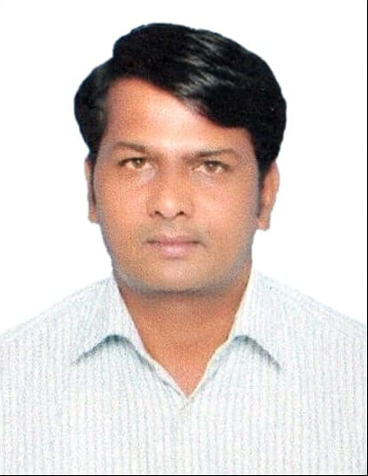

THIRUPATHI BATHULA
E-Mail: thiru123bt@gmail.com
Mobile No. +971566055318

CAREER OBJECTIVE

Seeking a career where I can utilize my experience and knowledge for growth and achievement to prove a valuable asset for organization for any challenging career.

EDUCATIONAL DETAILS

- SSC from Zilla Parishath High School in 2001
- Intermediate from Board of Intermediate Education in 2003
- Graduation from Kakatiya University in 2006(Dis continued)

Work Experience

- Shamsaa Pharmacy Drug Store (KSA) (2011-2018)
Store helper
- Maintained the warehouse in a neat and tidy condition
- Safely loaded and unloaded trucks.
- Picked, packed, and dispatched material as per order details.
- Stocking incoming orders into shelves

- ASGF General Al Safar (UAE)(2008-2010)
General Helper
- Al Safar Building contractions UAE, 2 years’ experience in company.
- Site night Watchmen & Loading unloading in charge.

Certifications

- SIRA(Security Industry Regulatory Agency).
- Basic Fire Safety Training
- Basic Life Support (Security Guard)

STRENGTHS

- Am flexible, adaptable and quick learner.
- Can build and maintain good relationship.
- Have great prospensity to learn new things.

PERSONAL PROFILE:

Date of Birth : 05th Aug 1983.
Gender : Male.
Language Known : Arabic, English, Hindi, Telugu
Current Location : Dubai.
Marital Status : Married
Passport No. : P0371424
Visa Expiry : 31/03/2024(Own Visa with NOC)

DECLARATION:

I hereby declare that the above particulars furnished by me are true to the best of my knowledge
and belief.

Date: Place: Duabi.
THIRUPATHI BATHULA

