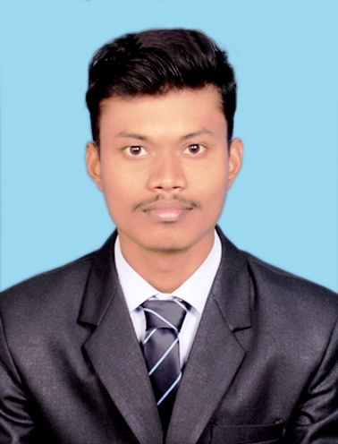
NIHAR RANJAN SAHU
Ph.: 6370089595
nsahu7347@gmail.com
OBJECTIVE
Interested in a challenging career with zeal in developing finance related solutions and serve the organization for growth

PROFESSIONAL SUMMARY
- A PGDM with FINANCE specialization
- Summer e-training at Jmarathon, has strengthened and broadened my knowledge in share market, mutual fund
- Fundamental in Digital marketing.

EDUCATION

PGDM (FINANCE) from USBM, Bhubaneswar, Odisha 2019 - 2021
B.Sc from T.S.D College, B.D pur, Berhampur University, Odisha 2018
12th Science from Manitara Science College, CHSE Board, Odisha 2015
10th from S.B.S High School Sankuru, BSE Board, Odisha 2013

SUMMER INTERNSHIP

Title: “MUTUAL FUND: AN ALTERNATIVE INVESTMENT VEHICLE”.
Company: J MARATHON ADVISORY SERVICES PVT. LTD 28/05/2020 - 13/07/2020
Learning outcomes:
- Basic knowledge on international market
- How to invest and when to invest
- Discussion about funds
- How to buy and sell share

CERTIFICATIONS

- Business Finance Foundation 2020
- Basics of Sales Order Management in Supply Chain Management. 2020
- Digital marketing 2020
COMPUTER SKILLS

- Adobe Photoshop
- Video Editing
- Ms office(word,excel,powerpoint)

EXTRA CURRICULAR ACTIVITIES

- NCC
- Attended NIC camp in Tezpur, Assam
- Attended ATC camp in G.udayagiri, Odisha
- Attended ATC camp in Chandipadara, Odisha
PERSONAL DETAILS

- DOB : 04TH August 1997
- Languages Known : English, Hindi, Odia
- Address : At-Kanakuturu, Po-Sankuru, Ps-Buguda, Dist-Ganjam, Pin-761118

