**CURRICULUM VITAE**

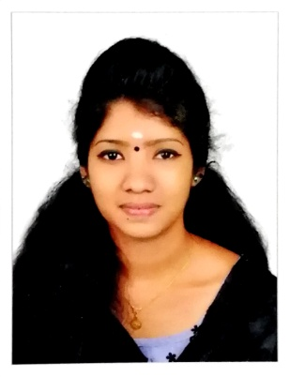

**GREESHMA C.**

CHOOZHIKKATTIL HOUSE

MULANHUR P.O.,

OTTAPPALAM, PALAKKAD.

PIN 679 511, KERALA

Mob: +91 70342 23749

**OBJECTIVE**

To associate with an organization that can fully tap my potentials and thereby to turn as an asset to the company I work for.

**EDUCATIONAL QUALIFICATION**

* **Plus Two** (Under Board of Secondary Education, Govt. Of Kerala – INDIA)
* **S.S.L.C** (Under Board of Secondary Education, Govt. Of Kerala – INDIA)

**SKILL SET**

* SALE STAFF

**PROFILE**

* **A good team player adaptable to any working atmosphere, with grasping ability, amicable and sincere attitude to work.**

**LANGUAGES KNOWN**

* **To speak ---- English, Malayalam, Tamil**
* **To read ----- English, Malayalam, Tamil.**
* **To Write ---- English, Malayalam, Tamil**

**EXPERIENCE**

* One year experience in sales staff in wedding lacha Section at Jayalakshmi Silks, Thrissur
* One year experience in sales staff in Ladies section at Safari mall Sharjah
* Currently works as sales staff in wedding lacha section at Pulimoottil Silks, Thrissur.

**PERSONAL DETAILS**

Date of Birth : 16.06.1999  
Sex : Female  
Father's Name : Balakrishnan  
Mother's Name : Sumathi  
Marital Status : Single  
Nationality : Indian

Religion : Hindu

Hobbies : Reading, Travelling...   
Permanent Address in India : Choozhiyattil House

Mulanhur P.O, Ottappalam

Palakkad - 679 511, Kerala

**Thanks for going through my C V, and also I am anticipating an early fruitful reply from your generous end.**

**Yours Faithfully,**

GREESHMA C.

Date: