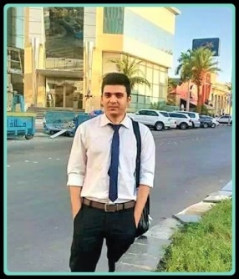 |  | EDUCATION

EASTPOINT COLLEGE OF HIGHER EDUCATION

01-12-2012–19-08-2015
MBA (FINANCE AND MARKETING

UNIVERSITY OF CALICUT

09-12-2009–26-12-2012
BACHELOR OF COMMERCE (CO-OPERATION)

DICA

11-01-2011
DIPLOMA IN COMPUTERISED PROFESSIONAL ACCOUNTING
(JEWAHARLAL NEHRU FOUNDATION)

shahabAS  Tally ERP 7.2 ,Peachtree  Windows 95 / 98 / 2000 / 2007 /2010 Internet Explorer  ERP applications – Citrix/BC50/OBIQ/FDR  THORAKKADAN  DOB:17/02/1991  INDIAN  JOB TITLE:  FRAUD AND RISK MGT/BPO/FINANCE/  OPERATIONS/SCHENGEN VISA EXPERT.  LANGUAGE KNOWN  ENGLISH  SPEAK WRITE READ  SPANISH  SPEAK WRITE READ  HINDI  SPEAK WRITE READ    https://www.linkedin.com/in/shahabas-bls-593124186   shahabasbls@gmail.com  shahabasinfy@gmail.com  +966 55 637 8372   +916235953900   KERALA,INDIA |  | WORK EXPERIEnce

EMBASSY OF SPAIN –BLS

APRIL 2017–TILL DATE
OPERATIONS

(Submission, Documentation ,Acceda,passport handling, Maintaining client relations, Handling shipments, Conducting training programs )

MASH SHIPPING AND LOGISTICS

MAY 2016–APRIL2017

JUNIORACCOUNTANT

.Accounts payables and receivables handling
.Updating related accounts
.Contacting customers for payment enquiry
.Conference with international clients

INFOSYS –(BANGALORE)PROCESS EXECUTIVE(BANK CARD CLAIMS) –SUNTRUST-USA 

09-02-2015–16-03-2016

AUDITING (FRAUD AND RISK MANAGEMENT)

. Accurate and timely updating on clients debit and credit.
.Accurate and timely reconciliation of all fees and figures relating to each client’s account.
. Maintaining international communication with onshore team
. Checking and updating merchant credit.

FUNCTIONAL EXPERIENCES

ERP applications ;-

Tally ERP 7.2
Peachtree

BC50
OBIQ
FDR
CHANNEL LINK

Proficient in Microsoft Office Package-
MS Word
MS Excel
MS Power Point
Outlook Express,

Windows 95 / 98 / 2000 / 2007 /2010
Internet Explorer.

