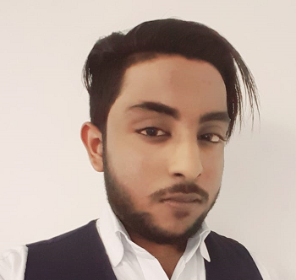**Mohammed Minshaf**

Mobile Number: (+94) 701715003

Sri Lanka Number: (+94) 714899605

E-mail Address: [minshafismath](mailto:minshafismath)@icloud.com

Current Address: Afanmanzil 61/3 Nadukar Watha

Ambepatiya Beruwala, Sri Lanka.

**Objectives:**

To be a part of an institution that places a vital role in providing knowledge among every individual and enhances personal growth and self-esteem that will support me in facing the highly competitive world.

**Working Experience:**

**Supreme Committee for Delivery and Legacy**

**Worker’s Welfare Division and Tournament Operations Planning Department**

**Al Asmakh Facilities Management**

**[ Receptionist/ Food & Beverage ( Waiter)]**

**April 24, 2018 – October 6, 2019**

**Duties and Responsibilities**

* Greet the staff and serve them their preferred drinks when they arrive in the office.
* Answering telephone calls for the order (coffee, tea, juices)
* Prepared and serve their food
* Taking Orders to the Meeting Rooms
* Maintaining the cleanliness of the pantry

**Hilton Hotel – Sri Lanka**

**(Food & Beverage**)

**February 2016 – February 22, 2018**

**Duties and Responsibilities**

* Serving to main restaurant
* Greet the Guest/s
* Do room service

**Eden Resort & Spa Hotel**

**(House Keeping/Room Boy)**

**November 2015 – January 2016**

**Duties and Responsibilities**

* Arrange Bed Decoration
* Clean Rooms
* Greet the guest

**Fancy Shop**

**(Salesman)**

**December 2014 – October 2015**

**Duties and Responsibilities**

* Selling cosmetic products
* Talking to customer and explaining to them about the product
* Giving them suggestion about what is suited for them

**Personal Data:**

**Address:** Afanmanzil 61/3 Nadukar Watha Ambepatiya Beruwala, Sri Lanka.

**Birth Date:**  October 7, 1998

**Birth Place:**  Sri Lanka, Kaluthara

**Civil Status:**  Single

**Citizenship:**  Sri Lanka

**Religion:**  Muslim

**Languages Speak:** English, Tamil, Sinhala, Maleyalam.

**Passport Number:** N7658966

**Sri Lankan N.I.C No.:** 982812801 V

**Educational Background:**

**Tertiary**

**London College, Dehiwala Sri Lanka**

Graduated as Hotel Management

2015 June

**Secondary**

**Al-Humaisara National School**

Kaluthara Beruwala, Sri Lanka

2013-2014

**Primary**

**Al-Humaisara National School**

Kaluthara Beruwala, Sri Lanka

2005-20012

**Skills**

* Can work under pressure
* Fast Learner
* Good Communication with people
* Motivated and good at solving problem
* Team player
* Computer Literate
* Can do multi-tasking job
* Flexible
* Self-motivated

**Extra-Curricular Activities**

* Participated in school Athletics Meets.
* Member of a sports Team.

*“I hereby Certify that the above written Information are true and correct as per my Knowledge, Experienced, and Ability.*

**Mr: Mohammed Minshaf**

Applicant’s Signature