ISMAYIL AP  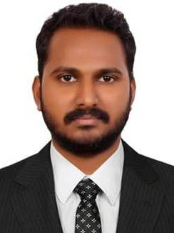  CONTACT  Address:  HORAL ANZ  ALI MLMULLA BUILDING  DUBAI  Phone:  +971- 566267304  Email:  Ismayilap21@gmail.com  LANGUAGES  ENGLISH  HINDI  MALAYALAM  HOBBIES AND INTERSTS  READING BOOKS  TRAVALING  PLAYING CRICKET |  | OBJECTIVE  Looking for a challenging and contributing an as organization desrind creative and innovative solution and opportunities for continues professional growth and career development. I could like to in an organization where my ideas and potential skills can be implemented and developed.  WORK EXPERIENCE  SALES EXECUTIVE  2 year experience as a Sales Executive in Nikshan Electronics ,Kannur,Kerala  SALES  1 year experience as a Sales in National Radio Electronics ,Kannur,Kerala  EDUCATION  SECONDARY LEVEL SSLC  KAMBIL MAPPILA HIGH SCHOOL KANNUR -KERALA.  +2 COMMERCE  HIGHER SECONDERY SCHOOL  2016-2018 BACHELOR OF COMMERCE (B.COM)  INSTITUTE OF TECHNOLOGY MAYYIL(ITM),KANNUR-KERALA  COMPUTER KNOWLEDGE  - Basic Knowledge about MS.Excel,MS.Word  - Tally,Peachtree,Quick Book(TPQ)  STRENGTH AND SUMMERY  - Ambitious, hard working and committed and excellence.  - Ability to work in fast paced team oriented environment  - Good problem solving skills  PERSONAL INFORMATION  Father’s Name : Ebrahim  Date of Birth : 29-03-1997  Sex : Male  Religion : Muslim  Marital Status : Single  Nationality : Indian  DECLARATION  I hereby declare that the above given information are true and correct to the best of my knowledge and belief.  ISMAYIL AP

