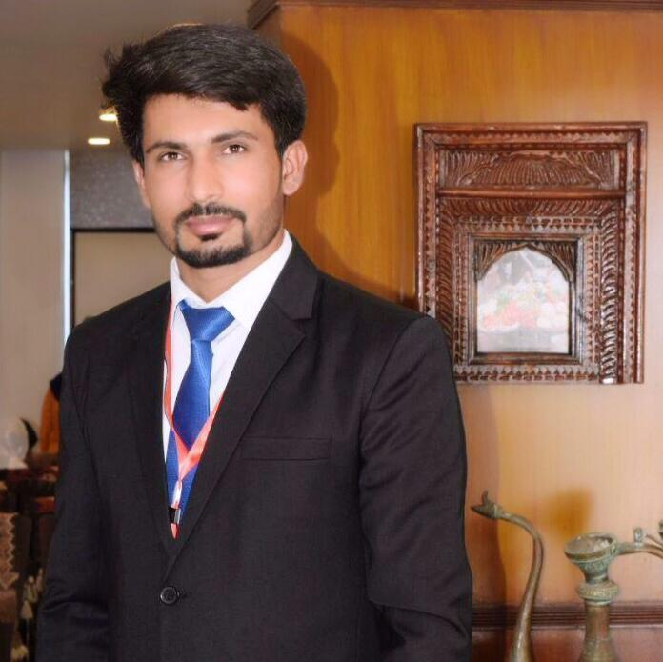

**OBJECTIVE**

**To work at a challenging position and provide effective and efficient services to the best of my capabilities and contribute in the success of organization.**

**EDUCATION**

**Degree Division/ CGPA Year University/Board**

MBA (Finance) 3.17/4 2015-19Lahore Garrison University

B.Com 2nd 2013-15 Punjab University. D.Com 2nd 2006-09 BTE Lahore

**MUHAMMAD MOHSIN GHAFOOR**

**Father's Name:**

**Abdul Ghafoor Bajwa**

**Phone No:**  +971 56 6263 859

**Whatsapp:** +971 56 6263 859

**Email:** [mbajwa999@yahoo.com](mailto:mbajwa999@yahoo.com)

**Address 1:** G4S Accommodation SunaPur Dubai.

**Date of Birth:**  01-04-1990

**Gender:**  Male

**N.I.C:** 34602-7349062-1

**Domicile:** Sialkot (Punjab)

**Nationality:** Pakistani

**Passport:** AX5740991

**Marriage Status:** Single

**Address 2:** Village Kamal Pur Bajwa P/O Chawinda Teh. Pasrur Dist Sialkot.

Matric  2nd 2004**-**06 Gujranwala Board

**WORK EXPERIENCE**

* Working as a Visitor Guide at **Dubai International Airport.**
* 10 weeks’ work experience as a Finance Internee in **“Ghani Global Group of Companies”.**
* One year and Six Months Experience as a Accounting and Mathematics teacher in **“Unique Girls Collage Lahore”**
* One-year experience as a exam Controller of **“Unique Girls Collage Lahore”**
* Two years and Six Months Experience as a Accounting and Mathematics teacher in **“Unique Academy”.**

**IT SKILLS**

* **Microsoft Word, Excel and Power Point.**

**ACHIEVEMENTS**

* Regional Finalist **HULT PRIZE Competition Melbourne, Australia** in 10 March 2018.
* **3rd Position in** **National Final Competition of HULT PRIZE**.
* **3rd Position in HULT PRIZE** out of 135 teams on Campus Competition in **Lahore Garrison University** 22 Dec 2017.
* Achieve Best Teaching Award from **“Unique Girls Collage Lahore”** session 2014 – 2015.

**INTERPERSONAL SKILLS**

* Ability of team work
* Ability to work independently
* Dedicated, Honest
* Self-confident and hardworking
* Willing to accept responsibilities
* Problem facing and problem solving skills

**REFERENCE**

* Will be provided when need.