**CURRICULAM VITAE**

**Sukethana S** 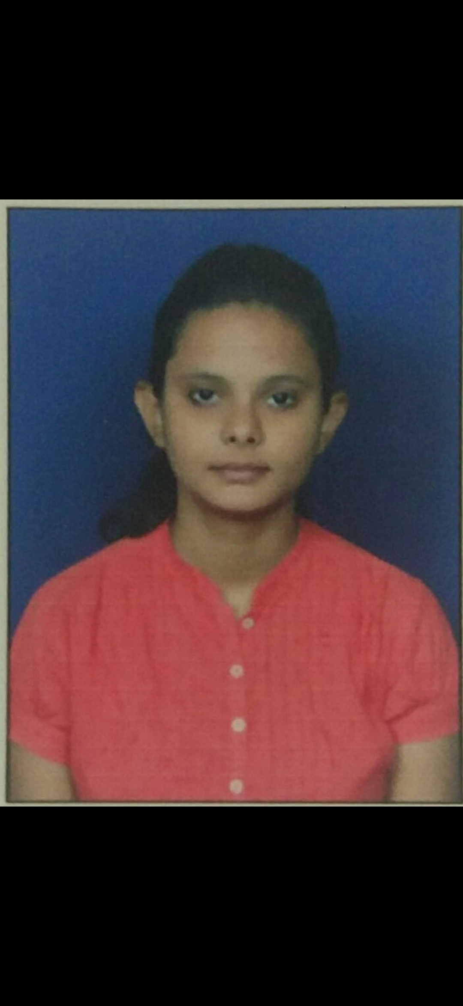

**Email: sukethanajain@gmail.com**

**Mobile No: +916361202370 / +919008766316**

**Career Objectives:**

**I would like a career that gives me rich exposure through diverse assignment and working with people of high caliber, and I look out for challenges which would help me to achieve my personal and professional goal.**

**Educational Credentials:**

|  |  |  |  |
| --- | --- | --- | --- |
| **Education qualification** | **Board/University** | **Percentage** | **Year** |
| **PGDBS** | **Manipal University, bangalore** | **81%** | **2017** |
| **B.COM** | **SRS First grade college,Chitradurga** | **65%** | **2015** |
| **PUC** | **SRS PU College, Chitradurga** | **73%** | **2012** |
| **SSLC** | **Rotary vidya bhavan, Chitradurga** | **46%** | **2010** |

**Awards and Recognition:**

* **I participated in Pegasus campus in Dehradun (NEW DELHI) in this camp I have learned management skills which related to corporate fields.**
* **I participated 2 days career development work shop in our college.**
* **Was appointed as student head for Marketing Events in Management fest in final year**

**Work Experience:**

**Canara hsbc obc life insurance joining date 1/7/2020 ( Relationship Officer Bancasurance)**

* **Exide life insurance joining date 10/1/2019, Reliving date 30/03/2020 ( Sales manager agency channel)**
* **Axis bank joining date 25/09/2017, Reliving date 30/09/2019 ( Assistant Manager Branch banking operations)**

**Technical Skills: MS Office, internet and Email operations**

**Hobbies and Interests:**

* **Photography**
* **Dancing**
* **Travelling**

**Personal Profile:**

**DOB:11th february 1995**

**Father’s Name: Sukhdev Raj S V**

**Mother’s Name: Sunitha S**

**Gender: Female**

**Nationality: Indian**

**Languages Known: English, Kannada, Telugu, and Hindi**

**Permanent Address: #34 %th cross jogimatti road Chitradurga 5577501**

**Declaration:**

**I do hereby declare that the information and facts stated above are true, correct and complete to the best of my knowledge and belief.**

**Place: Mysore Sukethana S**

**Date:**