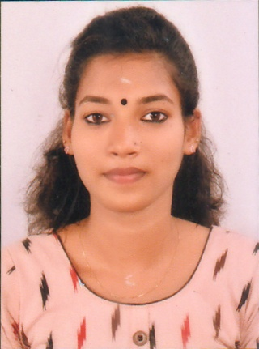**CURRICULUM VITAE**

**SREELEKSHMI.S.R**

**PERANICKAL**

**PRAYAR SOUTH**

**ALUMPEEDIKA.P.O**

**OACHIRA**

**KOLLAM (DIST.)**

**KERALA – 690547**

**Email –** [*sreelekshmioachira@gmail.com*](mailto:sreelekshmioachira@gmail.com)

**PH:- +91 8129524506**

***PERSONAL DETAILS***

NAME : **SREELEKSHMI.S.R**

FATHER’S NAME : Mr.Reghunathan Achary

DATE OF BIRTH : 19/02/2000

SEX : Female

MARITAL STATUS : Single

RELIGION : Hindu - Viswakarma

NATIONALITY : Indian

LANGUAGES KNOWN : English, Hindi, & Malayalam

PERMANENT ADDRESS : PERANICKAL

PRAYAR SOUTH

ALUMPEEDIKA.P.O, OACHIRA

***ACADEMIC QUALIFICATION***

* 10th PASSED (R.V.S.M.H.S.S. PRAYAR)
* 12th  PASSED (Govt.H.S.S. KULASEKARAPURAM)

***TECHNICAL QUALIFICATION:***

* I. T .I (SURVEYOR) From Matha Amirtha Mai Mission Trust, Puthiyakavu.
* Total Station & Dgps With Auto Cad
* Auto Level, Dumby Level & Theodolite
* BBD Surveyor
* MS Office, DTP

***TECHNICAL EXPERIENCE:***

* Workedas a Lader Land Survey Chennai, Tamil Nadu From 2018 Nov 10
* Worked as a Theertha Digital Land Survey, Kokkalai, Thrisur
* Worked as a SAS Survey and Engineers, Adoor, Kerala.

***EXPERIENCE IN:***

* DATA ENTRY
* SURVEY CUM TECHNICAL ASSISTANT

**DECLARATION:**

I DO HEREBY DECLARE THAT THE PARTICULARS FURNISHED ABOVE ARE TRUE AND CORRECT TO THE BEST OF MY KNOWLEDGE AND BELIEF.

PLACE: OACHIRA

DATE: 17/11/2020 **SREELEKSHMI.S.R**