RESUME
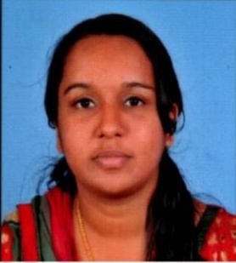  Jeena Sam  jeenamanoj009@gmail.com  9747881103  Permanent Address  Ozhankal  Pangada (PO)  Pararamattom  Pampady. Pin: 686502  Kottayam (Dist)  Kerala  Personal Data  Date of Birth : 22/4/1984  Sex : Female  Nationality : Indian  Marital Status : Married  Religion : Cristian | Career Objective  Looking for a challenging position in a banking / NBFC where my performed as Branch Manager and practical experience will fully utilized.  PERSONAL STRENGTH  Hard work, Sincerity my willingness to take risk and my devotion to the work are my strength  Academic Qualification  Course Name of the Institution Board/ University Percentage  M.COM Finance ST.ANTONY’S COLLEGE KANJIRAPPY M.G univercity (Private study)  B.COM Computer Application ST.ANTONY’S COLLEGE KANJIRAPPAY M.G univercity 48  XII SNDP HSS VENKURINJI Board of Public Examination, Kerala 45  X TVHS MUTTAPPALY Board of Public Examination, Kerala 50

WORKING EXPERIENCE

- 1 year working experience as an Accountant in Jalanidhi project under government of kerala from 2014 to 2016
- 1 year experience with senses department as surveyor from 2015 to 2016
- 3 year experience as Branch Manager with ASIRVAD MICRO FINANCE. LTD.at Ettumanoor brach from March 2016 to March 2019
- 1 and half year experience as senior sales executive at Axis Bank from March 2019 to 2020September
Linguistics
Language | Read | Write | Speak
Malayalam | √ | √ | √
English | √ | √ | √
Hindi | √ | √ | √
Technical Skills
COMPUTER KNOWLEDGE
- TALLY
- M.S OFFICE
- CERTIFICATE IN FINANCIAL ACCOUNTING
Declaration
I here by declare that aii the above mentioned details are true to the best of my knowledge and belief. I assure that I will discharge my duties to the satisfaction of my superious

Date:
Place: pampady JEENA SAM

