Curriculum Vitae
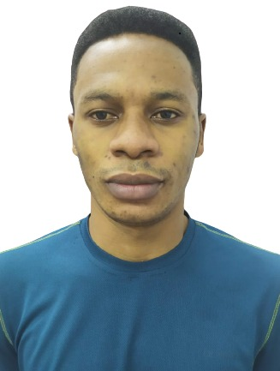  Contact Details:-  shiefshahine2021@mail.com  0562673439  Dubai, UAE 971  Personal Details  Date of Birth: 04.11.1992  Natinality : Cameroon  Sex: Male  Marital status: Single  Education Rename  HIGHER INSTITUDE FOR PROFERTIONAL TRAINING  Diploma of Higher Education CAMEROUN, August 2016  LYCEE TECHNIQE DES BDA-WEST A Level 1 / BACC CAMEROUN, August 2013  LYCEE TECHNIQE WEST A Level 2 / PROB / TV CAMEROUN, September 2011 | SHENY BERDEVEURE  PROFESSIONAL SUMMARY RENAME  Bilingual Restaurant Cook complying with all safety standards, including those pertaining to kitchen machinery, equipment and utensils. Considered grill master and expert baker.  WORK HISTORY RENAME  November 2019 - Current AVANI HOTEL RESTAURANT DUBAI - CHEF , DUBAI, UAE  - Planned and prepared food products orders to maintain appropriate stock levels.  - Checked freezer and refrigerator prior to each shift to verify correct temperatures.  - Utilised proper cleaning techniques to sanitise counters and utensils used in preparation of raw meat, poultry, fish and eggs.  - Prepared meals from scratch using authentic, popular recipes to generate repeat business.  January 2018 - November 2019 CAPITIANO RESTAURANT CONTINENTAL - KITCHEN ASSISTANT, DUBAI, UAE  - Mastered 10 TO 20 recipes to professional standard.  - Assisted [head chefs] in timely preparation of up to [100] meals weekly .  - Cleaned and organized kitchen stations within [45]-minute timeframe, promoting team efficiency.  - Reported [to] maintenance needs and unsafe work conditions within -minute timeframe.  - Assisted chefs with preparing and presenting food to regular guests, employing meticulous attention to detail and presentation expertise.  January 2016 - February 2018 PRIMMIER IIN - STORE KEEPER, ABU DHABI, UAE  - Remained flexible to commit to hours overtime to maintain smooth workflow in busy periods.  - Sustained safety protocols while delivering proper, cost-effective and safe handling equipment and material use.  - Explained information about quality, value and style of products to influence customer buying decisions
LANGUAGES RENAME  - English:  - French  - Arabic ( Beginner)  Passport Details  Passport No: 0921788  Issue Date: 15.03.2019  Expiry Date: 15.03.2024 | SKILLS RENAME  - Hospitality service expertise.  - Passionate, spirited and classically trained culinary professional  - high-performing teams.Leader in the delivery of excellent customer service,  - Dedicated to food safety, customer service best practices and quality food .  - HACCP  - Effective communications  - Purchasing  - Kitchen inventory control  - Food safety & hygiene expert  CERTIFICATIONS  - [FOOD SAFETY] Training - [2021]  - Certified[ CHEF], [AVANI HOTEL] - [2021]  Reference  Cresco safe occupational safety trading L.L.C  Dubai-U.A.E

