**CURRICULUM VITAE**

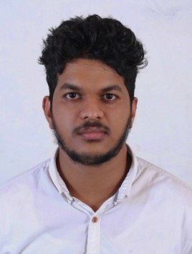JASEELUDHEEN KAKKUZHIYIL

Accounts /Administration Professional

MOB :+91 8589843076

WHTSAPP:+91 8589843076

Email: jaseeludheenk5@gmail.com

**AREAS OF INTEREST**

**ACCOUNTANT**

|  |
| --- |
| **CAREER OBJECTIVE** |

To be associated as an employee with a progressive organization that gives me scope to update my knowledge and skill in accountancy with a latest ideas and part of team that dynamically works to towards growth of organization and gain satisfaction thereof.

|  |
| --- |
| **COMPUTER SKILLS** |

* Quick Books
* Microsoft word
* Microsoft Excel
* Tally ERP9
* Peachtree

|  |
| --- |
| **CAREER HISTORY** |

* **Shaheen Supermarket, Sur Oman**

Position : Cashier/Accountant

Duration : 9 Months

|  |
| --- |
| **PERSONAL PROFILE** |

Date of Birth : 13/01/1998

Father Name : Moidu Kakkuzhiyil

Gender : Male

Marital Status : Single

Religion : Muslim

Nationality : Indian

**LANGUAGES**

* English
* Hindi
* Malayalam
* Arabic

|  |
| --- |
| **COMMUNICATION ADDRESS** |

JISHANA MANZIL

MAYYANNUR PO

VADAKARA

CALICUT, INDIA

PIN: 673542

|  |
| --- |
| **EDUCATIONAL QUALIFICATIONS** |

* **Graduation**

B.COM (Bachelors of Commerce)from Calicut university kerala, INDIA[2015-2019]

Specialization: Co-Operation

* **PDCFA**

Complete professional Diploma in computerised Financial Accounting In 2019

|  |
| --- |
| **PASSPORT DETAILS** |

Passport No : S0227415

Issued Date : 13/03/2018

Date of Expiry : 12/03/2028

Place of Issue : KOZHIKODE

|  |
| --- |
| **STRENGTH** |

* Good all round financial Accounting knowledge
* Knowledge of Accounts payable and Receivable processes and procedures
* Experience in using Tally erp9,Quickbook,and Peachtree
* Good communication skills

|  |
| --- |
| **Responsibilities** |

* Preparation of balance sheets.
* Preparation of Final Accounts-Computerization of Accounts of almost all types of business organization using Tally9.0[ERP]
* Preparing and issuing Invoice
* Issuing monthly statement
* Keeping customer file update with current invoice
* Valuation of company assets and liabilities

**DECLARATION**

I here declare that all the information given above are true and correct to the best my knowledge and belief. Character reference will be readily furnished upon request.

Place: **JASEELUDHEEN KAKKUZHIYIL**

Date: