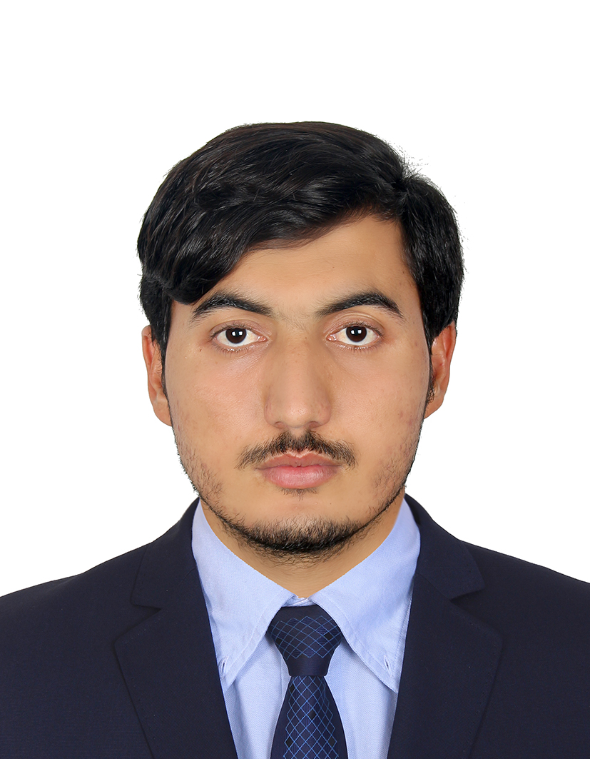  Fida Ullah | Dubai, Unites Arab Emirate  +971565857086  akashfida2@gmail.com
I am an enthusiastic individual striving for my career goal by acquiring a professional position in an organization where I can utilize my capabilities and skills to contribute to the wellbeing of the organization and the growth of my professional career. I take challenges as opportunity which further polish my skills set.

Personal Information
- Father’s Name:  - Sex:  - Date of Birth:  - Domicile:  - Religion:  - Nationality:  - Marital Status:  - Visa Status: | Sher Ayaz Khan  Male  20/09/1997  Bannu  Islam  Pakistani  Single  Residence Visa

Passport Details
- Passport No:  - Place of Issue:  - Date of Issue:  - Date of Expire: | LQ2745171  Pakistan  20/09/2018  25/06/2023

License Details
- License No:  - Place of Issue:  - Date of Issue:  - Date of Expire: | 4176375  Dubai  28/09/2021  28/09/2023

Education

2017

BSC (Chemistry & Biology)/ USTB, Bannu, KPK, Pakistan
Score: 274/550

2015

Intermediate /Bannu Board, KPK, Pakistan
Score: 574/1100

2013

SSC / Bannu Board, KPK, Pakistan
Score: 635/1100

Skills
- Good in MS World Documentation  - Experience in MS Excel  - Problem solving  - Expert in Internet searching and email etc. | - Project management  - Experience in Power Point Presentation  - Good in listening of Problem and their solving  - Good in Teach/ Presentation

Languages
- English (Read, Write, Speak)
- Urdu (Read, Write, Speak)
- Pashto (Read, Write, Speak)

