CURRICULAM VITAE
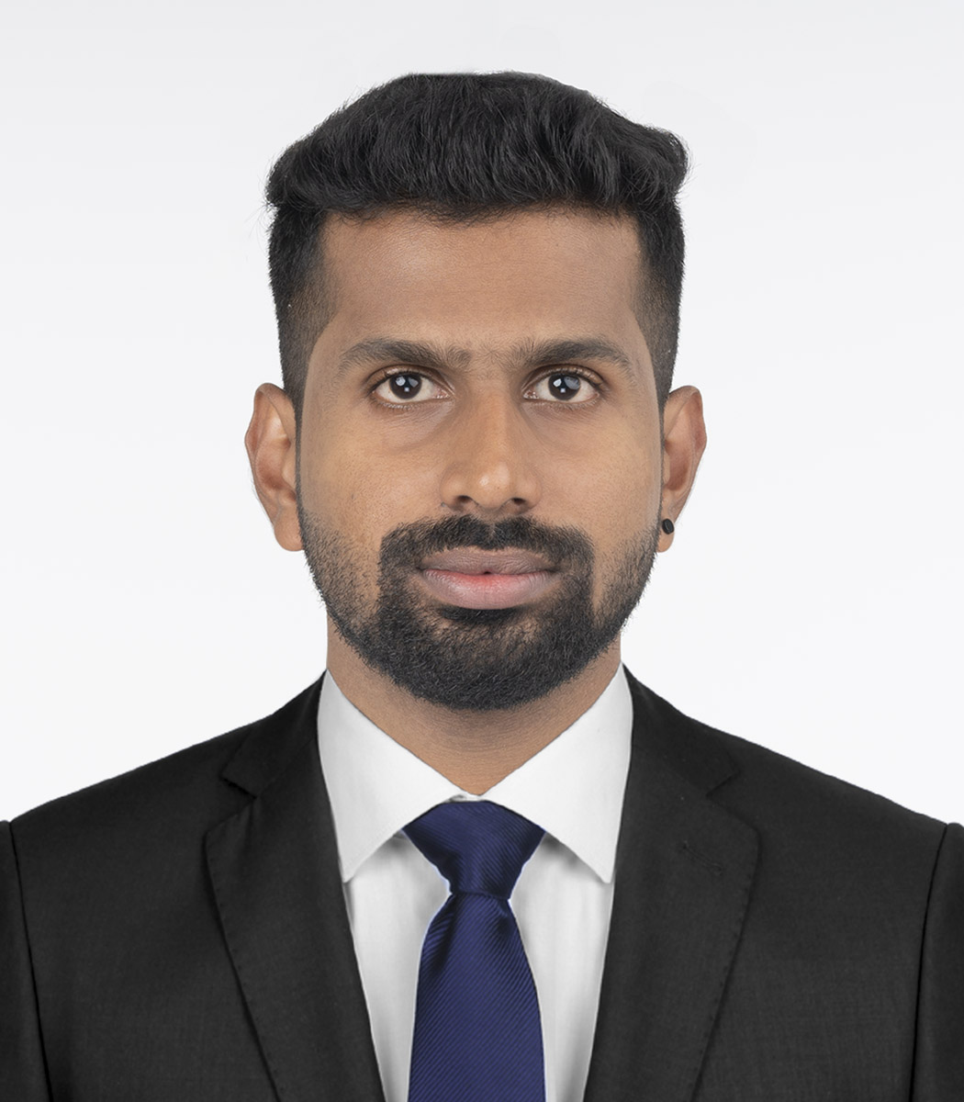

ACCOUNTANT
UMESH PS
Linkedin.com/in/umesh-pc-42a840178
umeshps14@gmail.com

CONTACT NUMBER:  +91 8893493369  +91 8921693358  PERMANENT ADDRESS  Palathingal (H),  Vengoor (PO)  Perumbavoor,  Ernakulam (Dist)  Pin- 686692.  Kerala, India.  PERSONAL DATA  Date of Birth: 25-05-1995  Gender: Male  Nationality: Indian  Marital Status: Single  Passport-No: R3535663  Place of Issue: Cochin  Date of Issue: 06-09-2017  Date of Expiry: 05-09-2027  LANGUAGES KNOWN  English  Hindi  Malayalam  Tamil | CAREER SUMMARY  Highly motivated Accountant candidate with around 3 years of experience in the functional area.  PERSONAL QUALITIES  - Excellent mathematical skills and intuitive reasoning.  - Capable of analyzing complex situations and finding unorthodox solutions to complex problems.  - Highly skilled in communications and recordkeeping.  - proven ability to quickly learn and use new technologies and tools  - Ability to work individually as well as in team.  - Positive and professional at all times.  EDUCATIONAL QUALIFICATIONS  - Degree of Bachelor of Business Administrator (BBA) -2018  (Mahatma Gandhi University)  - Provisional State Trade Certification - Electrician - 2014  (Industrial Training Institute/ITI, Govt. of Kerala)  - Higher Secondary Education – Plus Two – 2012  (Board of Higher Secondary Examination, Govt. of Kerala)  - Higher Secondary Education – SSLC – 2010  (Board of Secondary Examination, Govt. of Kerala)
TECHNICAL EXPERIENCES
- Expert Knowledge in computer related operations.
- Windows 10, MS 2010-Word, Excel, Power Point, Publisher
- Adobe Page Maker, Adobe Acrobat Reader Professional version.
- Internet Operations & E-mail handling.
- Tally Prime
- VAT Mate

WORK EXPERIENCES
ORGANIZATION-1
Worked with M/s. Seatektrans Equipments as Accountant
From 01st April 2018 to 30th September 2019

ORGANIZATION-2
Worked with M/s. Team Lease Services Limited as Accountant for Bajaj Finserv Ltd.
From 25th October 2019 to 13th January 2021

KEY RESPONSIBILITIES HANDLED
- Preparing financial documents such as invoices, bills, and accounts payable and receivable
- Completing purchase orders
- Managing payroll
- Completing financial reports on a regular basis and providing information to the finance team
- Assisting with budgets
- Completing bank reconciliations
- Entering financial information into appropriate software programs
- Managing company ledgers
- Processing business expenses
- Coordinating internal and external audits
- Verifying balances in account books and rectifying discrepancies
- Verifying bank deposits
- Managing day-to-day transactions
- Recording office expenditures and ensuring these expenses are within the set budget
- Assisting the finance department and senior accounting staff members with various tasks, including preparing budgets, records, and statements
- Posting daily receipts
- Preparing annual budgets
- Completing the year-end analysis
- Reporting on debtors and creditors
- Handling accruals and prepayments
- Managing monthly budgeting tasks
- Encoding accounting entries for data processing
- Sorting financial documents and posting them to the proper accounts
- Reviewing computer reports for accuracy and meticulously tracing errors back to their source
- Resolving errors in financial reports and correcting faulty reporting method

ACHIEVEMENTS & CERTIFICATIONS
- Remarkably prepared the document and accounts history.
- Got appreciation from seniors for doing excellent work.
- Attained the Certification and License of Wireman from Kerala State Govt. Electricity Board
- Attained the Certification of Graphic Designing from G-Tech Computer Education

DECLARATION
I hereby declare that all the information furnished is true to the best of my knowledge.

(UMESH PS)

