CURRICULUM VITAE

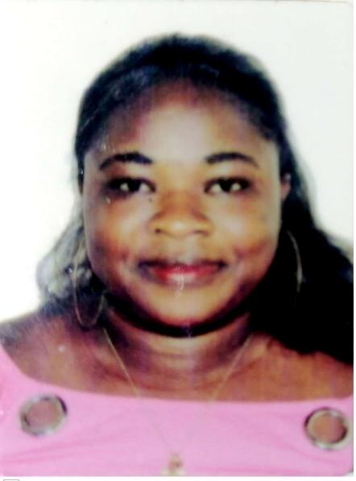

# PERSONAL DATA

# NAME: JOSEPHINE ANTWI

# DATE OF BIRTH: 03 AUGUST 1983

# NATIONALITY: Ghanaian

# VISA STATUS: VIST VISA

# PASSPORT ID: G2984879

# ADDRESS: KHALIDIYA-ABU DHABI

# TELEPHONE: +971-565418908.

# APPLYING FOR THE POSITION AS CLEANER

# CAREER OBJECTIVE:

# Ambitious and promising sales personnel with culinary education and prestigious intern and entry-level work experience. Trained in multiple cuisines and preparations and extremely knowledgeable of basic and advanced marketing, retail and sales work. Able to prioritize organizational goals and ambitions whiles developing self-skill and abilities. Takes direction well and can work under extreme pressure while maintaining a positive attitude.

# WORK EXPERIENCE (5 years)

# CLEANER

# December 2021 – May 2022

# EXPO 2020. Dubai – UAE

# Help Customers to select and obtain items of their desire.

# Assist customers in making payment by various means of payment.

# Greeting customers in store

# Rotating and replenishing stock.

# CLEANER

# 2018 – 2020

# ACCRA MALL

# Providing customers with information on pricing and product availability

# Recommend and display items that match customer needs

# Maintain a fully stocked store

# Maintaining outstanding store condition and visual merchandising standards.

# Establish, develop and maintain positive business and customer relationships.

# Present, promote and sell products/services using solid arguments to existing and prospective customers.

# 

# SUMMARY OF SKILLS

# Security alertness and excellent English communication

# Customer satisfaction.

# Good logical reasoning, result oriented

# Understanding the importance of health, hygiene and plenty of stamina

# A great team player and the ability to listen and learn – fast

# EDUCATION BACKGROUND

# SENIOR HIGH SCHOOL.

# REFEREES:

# Available upon your request

# I hereby certify to the best of my Knowledge and belief that, information given in this Curriculum Vita above is true, and authentic.



Only two pages were converted.

Please **Sign Up** to convert the full document.

**[www.freepdfconvert.com/membership](https://www.freepdfconvert.com/membership)**