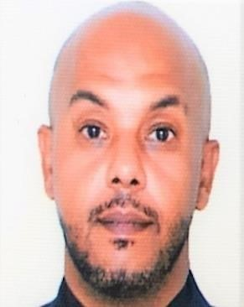 |  | Ahmed Shoukry Mohamed Hussein
Profile  A passionate and dedicated customer service professional with over 15 years of solid experience Customer service position. Ready to contribute to maximize profitability, ensuring customer satisfaction and achieving targets.  A passion for people development, proactive and resourceful, an effective and confident hands-on leader with solid people management and motivational skills.  Contact  +639 05296 4331  ADDRESS:  18B SPUD St. EAST FAIRVIEW Subdivision Brgy Fairview Quezon City, Manila, Philippines  email:  ahmed.shagy@yahoo.com  visa status  RESIDENT VISA HOLDING  TEMPORARY RESDENT VISA  VALIDITY: DECEMBER 2024  Government id’s:  ◘ TIN ID  ◘ SSS  ◘ PHIL HEALTH ID  ◘ PAG – IBIG FUND  EDUCATION  Higher Institute of Specific Studies  BSC Holder of Dramatic and Arts Cairo-Egypt  2003  SKILLS  Advance knowledge in computer and printers  Time management and know how to handle pressure, strong analytical and conversational skills, selling and negotiating skills, leadership skills. |  | WORK EXPERIENCEs  IHG (Intercontinental Group)  ARABIC AND SALES RESERVATION SUPERVISOR  August 2023 – January 2023  Roles and Responsibilities  • Solve customer problems quickly and effectively, ensuring guest satisfaction.  • Embrace global diversity of guest and focuses on providing meaningful and authentic experiences.  • Answering customer inquiries, scheduling, meetings, and sales appointment and following up with customer about their booking status.  QATAR AIRWAYS  DECEMBER 2017 – MAY 2020  CUSTOMER DUTY OFFICER AIRPORT  MAY 2014 – DECEMBER 2017  Customer Services Duty Officer  JULY 2012  Customer Services Duty Supervisor  MARCH 2010  Senior Airport Services Agent  JUNE 2008  A/Senior Airport Services Agent  OCTOBER 2005  Airport Services Agent  Roles and Responsibilities  • Check the applications for authenticity, submitted document proofs.  • On completion of documentation and authenticity check, send the application for further approval  • Provide complete assistance to the client until the claim is settled and the money is credited in the client's account.  • Update the records after approval of claims.  • Supervises and handles the check in process for all new arrival’s guests.  • Organize the catering requirements outlined and Housing for all new arrivals and guests.  • Liaises within the Hospitality department Security, Transportation, and other Services to ensure cleaning maintain.  • Maintain all documents, boards with regards to flight movements as information to staff and record purposes.  • Received and handling instructions to and from other sections and other airlines for action.  • Obtain all necessary information regarding VIP, CIP and special handling.  Egypt AIR  SEPTEMBER 2003 - JULY 2004  Customer Service Agent  Roles and Responsibilities  • Obtain all necessary information regarding VIP, CIP and special handling.  • Follow company rules and policies by all employees  • Follow all data's entry & maintenance of customer/ positional data bases.  • Boarding and releasing flights for on time departures while providing excellent customer service.

