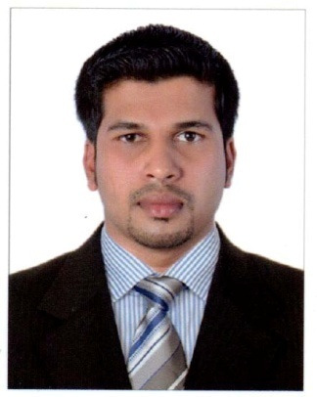

**Arun Puthenpurakkal Asokan**

### Mobile: +919061584735

**e-mail:arunhoodibaba2255@gmail.com**

Indian Passport Number : U7492445, Date of Expiry : 06-December-2030

**PROFESSIONAL SYNOPSIS**

A seasoned professional having graduated in BSC Hotel management & catering science, a person having thirst for knowledge, punctual, possesses excellent management skills.

Appreciated from the various managements for punctuality, attitude & sincerity.

**AREA OF INTEREST**

Food & Beverage Service

**COMPETENCY FORTE**

|  |
| --- |
| * Team Management * Quicker grasping ability * Interpersonal and Conflict Management Skills * Expertise in designing attractive presentation and demonstration * Extrovert * Leadership qualities * Good time management and punctuality * Excellent problem- Solving skills * Technical : Microsoft office |

**Profile as the Cashier in Kairali Palace Restaurant, Oman (March 2019 to January 2020. )**

* Good customer service, helping them locates items.
* Balancing the cash register and generating reports for credit and debit sale.

**Profile as the Restaurant incharge in Sreepathi Inthreprastha Guruvayoor Kerala, India**

**(May 2018 to November 2018)**

* Ensuring compliance with licensing hygiene and health and safety legislation.
* Greeting and advising customer, planning menu.

**Profile as the Senior Captain in Munnar Black Forest Resort Munnar, Kerala, India.**

**(May 2017 to October 2017)**

* Responsible for guiding the hostess, waiter/waitress and bus boy/girls in the performance of their jobs.
* Responsible for the overall sanitation and cleanliness of the outlet during the shift.

**Profile as the Cashier in Cateriya Catering Service LLC, Dubai, United Arab Emirates**

**(January 2014 to January 2017)**

* To be Responsible his or her own results
* To ensure that guests receive high quality service

**Profile as the Waiter in Cateriya Catering Service LLC, Dubai, United Arab Emirates**

**(Nov 2012 to Dec 2013)**

* Greets guests and presents them with the menu.
* Suggest food and beverages to the guest and also try to upsell.
* Take food and beverage orders from the guest on the order taking pads or on the handheld system.

**Profile as the Captain in Birds Valley Resorts Munnar, Kerala, India.**

**(April 2011 to Oct 2012)**

* Responsible for ensuring sufficient operating guest supplies, beverage supplies and operating equipment

during outlet’s operation.

* Responsible for the proper maintenance and good working order of all equipment, furniture and

fixtures in the outlet.

**ORGANISATIONAL SCAN**

**Quality INN Sabari, Chennai, Tamil Nadu, India**

Management Trainee in F&B Service Department – 6 Months

**Significant Highlights:**

* Passed Certified Basic Hygiene course (Gov. of Dubai, UAE)
* Have attended Cocktails and Mock tails workshop at Coimbatore Nehru College
* Coordinated more than 50 outdoor catering
* Expert in languages English, Malayalam, Tamil, Hindi

**ACADEMIA**

* B.Sc. from Nehru Arts & Science College Coimbatore, Tamilnadu, India in (2008-2011)
* Higher Secondary from Sraddha group of institutions ,Palakkad,kerala,India (2006-2008­
* SSLC from GBHSS Nemmara,Palakkad,Kerala,India

**PERSONAL PROFILE**

Date of Birth : 29th May 1991

Permanent Address : Puthenpurakkal House, Payyamcode, Kairady (P.O)

Palakkad, Kerala -678510, India.

Marital status : Married