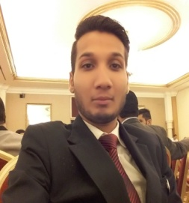


MUHAMMAD MUJTABA QURESHI
Cell: 03462430596
Address: A 21-Adnan shoping mall sector 15-A/1, Gulshan-e-sir Syed,
Buffer Zone, North Karachi.
Email: Mujtabahashmi0@gmail.com

Career Objective

Accept and enjoy the new situation and challenges, make positive contribution towards the given position, increase the wealth of the organization and enhance the knowledge, abilities and skills through organization by contribution.

Personal Information:

Father’s Name : MUHAMMAD INAM QURESHI
Date of Birth : 27th October 1992
CNIC# : 42101-0724584-7
Marital Status : Single
Religion : Islam
Nationality : Pakistani
Language : English and Urdu

Certificate / Degree | Subjects | Board / University
B.com | Commerce | University Of Karachi (Process)
Inter | Commerce | Board of Intermediate Karachi
Matriculation | Science | Board of Secondary Education Karachi

Academic Qualification:

Computer Skills:
- Hardware & Software Installations
- Ms-Office
- Internet Searching
Hotel skills:

- Room Division Course from PITHM.

Experience:

- Working in MOVENPICK as a Protocol Officer. (Since January2015)

References:
- I Will be furnished upon request.

