 CURRICULUM VITAE
ARUN AK 
Mobile: +91-9790638080
E-mail: akarun.037@gmail.com
Skype: akarun47
Passport No: U5715332
LinkedIn: https://www.linkedin.com/in/arunakseospecialist/
Website: https://akarun037.wixsite.com/seospecialist

Objective:

To work in a professional environment where I can contribute to myself and enrich my work towards the organizational goal. My passion lies in the digital marketing as I have always been an early adopter of any new technology that hits the market. This, coupled with my love of words and combinations, makes me a perfect fit for dynamic content creation in digital marketing. I am still young in my professional development and seek an employer that will provide me the opportunity to add skills to my repertoire that will allow me to be a more valuable team member in the future.

Job Summary:

- Experienced and a very motivated SEO Analyst who is persistent in keeping up to date on any SEO changes by the major search engines. Adept at website development, troubleshooting website programming and organizing website content.

- An expert in Internet Marketing campaigns, specializing in Organic Search Engine Optimization (SEO), Search Engine Marketing (SEM), Social Media Marketing, Article Marketing & Market Research.

- Understands Client's marketing objectives and fully analyzing their online sector and competitors.

- Maintains an excellent knowledge of the major search engine algorithm and ranking systems.

- Proficient in Google Analytics & Google Webmasters tool with a strong knowledge of SEO tools like Raven, web position, open explorer, AHREF etc.

- Coordinates with Web Developer and Web Designer to make website more Search Engine Friendly and User Friendly.

- Handles content writers and freelance writers for developing good content considering Keyword Density, Keyword Prominence, Keyword Proximity and Keyword Stemming etc. factors.

- Prepares SEO Proposals for clients and Pre Analysis Report of Websites.

- A fast learner with the ability to work autonomously or as a pivotal part of a wider team.

- Excellent analytical and critical thinking skills

PROFESSIONAL ACHIVEMENTS

When i joined the company Jointviews traffic for the website Edsys, Redbytes, ProBytes that has been designated to me was (Refer the Picture given below) per month. With my strategic approach and experience and proven method i was able to raise the traffic to (Refer the Picture given below) per month.

- Analytics Report For Edsys (From Sep 2017 – Feb 2020)

URL: https://www.edsys.in/

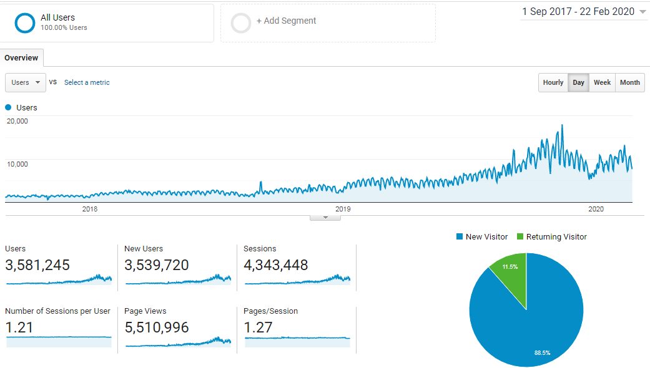

- Analytics Report For Redbytes Software (From Sep 2017 – June 2019)

URL: https://www.redbytes.in/

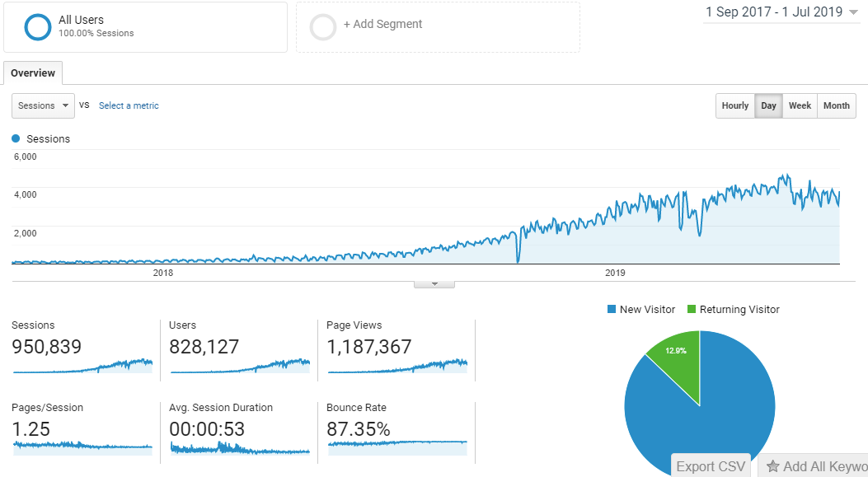

- Analytics Report For ProBytes Software (From Sep 2017 – June 2019)

URL: https://www.probytes.net/

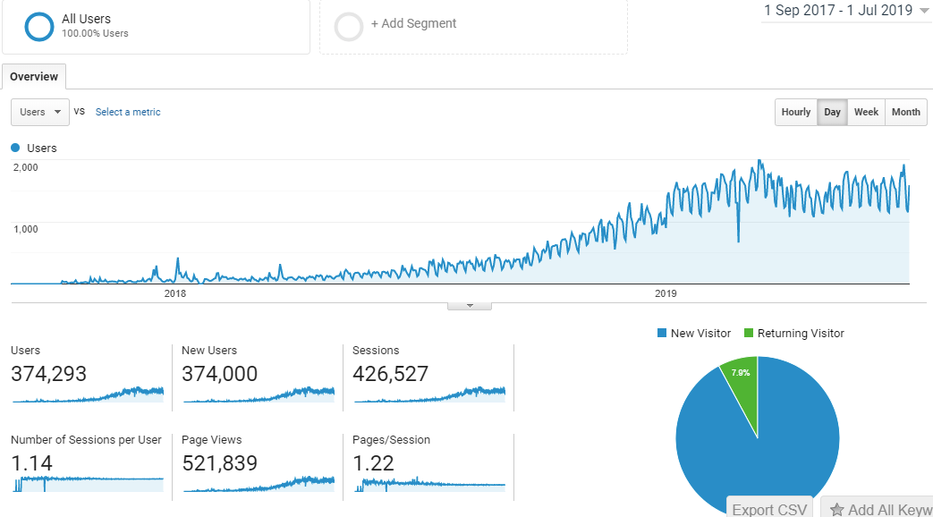

Information Architecture (IA)

- Working with customers to understand their business models and goals for helping to define strategy, content, and features for designing of their web site.

- Analyze audiences and their information and functional needs.

- Define site architecture and navigation regarding business models and goals.

Highlights

Search Engine Optimization (SEO) Tasks | On page Optimization | Off page Optimization
- Website Analysis  - Keyword Research  - Competitor Analysis  - Competitor’s SEO performance analysis  - Website performance Monitoring  - Local Search Engine Promotion  - Broken Link check  - Google Local Places Listing  - Google Product Listing  - Monitoring and Monthly Reporting  - Handling various SEO tools(Paid & Free both) | - Meta Tag Optimization  - Content Optimization  - Internal Linking  - Website Navigation Optimization  - XML and HTML Sitemap generation  - RSS Creation  - Web Speed Test and Improvement  - Robots.txt Creation  - Image Optimization  - SEO Friendly URL Creation  - Schema | - Directory Submission  - Bookmarking Submission  - Video Submission  - Image Submission  - Search Engine Submission  - Article Submission  - Press Release Submission  - Blog Promotion  - Blog Comments  - Forum Discussion  - Review Posting  - Classified Submission  - RSS Feed Syndication  - Info Graphics Submission  - Documentation Submission

SEARCH ENGINE OPTIMIZATION(SEO)
- Composing effective headlines and subheadings! Writing compelling Title Tags and Description Meta Tags to induce more clicks in search results
- Optimizing Web Pages – Integrating Keyword Phrases, Executing On-Page SEO Mechanical Elements (H-tags, Images, Text attributes)
- Keyword Mapping: Mapping keywords to specific pages strengthening content silos
- Performing keyword research in coordination with company’s business objectives to optimize existing content and uncover new opportunities
- Diagnosing Technical SEO Issues and resolving: Canonicalization, Pagination, 404 Errors, Server Errors, Duplicate Content, Robot.txt file, XML Sitemap and HTML Sitemap problems
- Periodic Monthly SEO Reports & Web Analytics Reviews – Track Keyword Ranking Changes
- Using SEO tools effectively – Google Webmaster Tools, Google Analytics interpretation, Bounce rate, Crawl errors, SEO queries, Impressions. Proprietary and third-party SEO tools identify trends and building blocks for achieving higher organic rankings – Opensiteexplorer.com, Keywordspy.com, Semrush.com, Majesticseo.com, spyfu.com
- Building systems and protocols internally that ensure all content is optimized across all platforms and user experiences (websites, mobile, social, video, blogs, etc.)
- Keeping pace with SEO, search engine, social media and internet marketing industry trends and developments
- Working closely with the other Marketing team members to meet management goals

PPC

- Conducting keyword research and selecting product-specific keywords for PPC campaigns
- Monitoring campaigns on a regular basis to measure and maximize the effectiveness of all PPC campaigns
- Composing and testing ad copy to produce optimal click through rates
- Monitoring campaign results, analyse key metrics, and optimize click-through and conversion rates
- Has strong knowledge in Google, LinkedIn, Facebook & Twitter paid search
- Creating, monitoring and optimizing PPC campaigns across Google Adwords and other paid channels for various regions (US, EU, MEA, APAC, OFAC)
- Managing and optimizing the existing internet marketing campaign components including keyword strategy, bid prices, impressions, cost per conversion, cost per click, CTR, etc.
- Performing daily account management and of pay per click accounts on Google AdWords, Yahoo, Bing and other search platforms
- Maintaining and monitoring of keyword bids, account daily and monthly budget caps, impression share, quality score and other important account metrics.
- Generating sales leads through Google PPC and LinkedIn PPC and accelerate pipeline opportunities for the sales team
- Optimizing the landing page and Ads to increase the quality score on Google PPC
- Identifying the least expensive but most powerful and profitable keywords
- Creating and managing display ads for specific campaigns to meet the company goals
- Strategies for keyword opportunities, campaign structuring, targeting, display network, and other facets of paid search in accordance with company goals.
- Tracking the ads performance through A/B testing
- Determining ROI on search marketing efforts.
- Reaching the target audience and promoting our products and events via Google Remarketing

Email Marketing

    - Maintaining a list of opt-in email addresses and leads
    - Writing action-oriented, compelling emails to promote various products and brands
    - Researching for ideas for deals and offers exclusively for subscribers
    - Sending emails twice a month
    - Sending emails a week before special days and holidays
    - Monitoring click-through and conversion rates using Google Analytics

Website Management

- Ensuring that all websites and internet properties under my influence have been technically optimized to attract and engage the target audience
- Recommending Call-To-Action features and CTA Buttons to improve conversion rates
- Tracking the user behavior for conversion optimization through Crazyegg and Hotjar
- Changing the menus and CTAs based on the user behavior
- Knew operational features of Content Management Systems: WordPress, Drupal

Analytics

- Google Analytics | - Google Webmaster Tools | - Bing Webmaster Tools | - Hoot Suite Analysis
- Dux-Soup | - Twitter Analytics | - Google AdWords | - Google Tag Manager
- Semrush Paid | - Unamo Paid | - Google Studio | - SpyFu

Social Media Marketing

- Has a strong understanding of social networking and social media marketing (LinkedIn, Facebook, Twitter, YouTube, Pinterest, Instagram etc…)
- Generating quality sales leads through social media sites
- Manage social media campaigns and day-to-day activities
- Planning & execution of social media marketing for attaining company’s marketing goals
- Planning and creating paid campaigns on Social Media platforms (LinkedIn Sponsored updates, Promoted Tweets, Facebook Sponsored post and YouTube sponsored videos)
- Actively manage company’s profile on various social networking sites
- Campaign specific strategies for marketing on social media
- Coordinating with product managers & Marketing communication team to get the social feeds & manage the social calendar
- Promoting thought leadership collaterals like solution briefs, datasheets, whitepapers, Case Studies, Fact Sheets, Insights, Analyst Reports, Survey, Illustrations, webinars, etc across all social media channels
- Initiate conversation through blogs/forums, twitter and other postings.
- Moderating MetricStream owned LinkedIn groups (10+ groups)
- Monitoring the conversions in LinkedIn groups & alert the Product managers / sales team on relevant topics
- Creating marketing content to socialize and use for social media purposes (Thought leadership collaterals)

Employment History:

SEO Specialist/MUB Corp Jan 2021- Still Working
Bangalore, Mittal Tower, India

Responsible for improving Page Rank and keywords in SERP by using on page and off page optimization techniques

- Specialized in paid search, display, paid social campaigns.

- Improved landing page, Ads copy, bid strategy with A/B testing.

- Conducted new advertising channel research and implementation to increase user acquisition and generated traffic.

- Managed Facebook ads, AdWords and LinkedIn ads while ensuring marketing message consistent with the company goals and objectives.

- Optimized campaigns and create weekly reports.

- Implemented research and user data analysis using Excel, SQL to identify target markets.

- Used Google Analytics and semrush to analyze paid search campaign, display campaign and mobile campaign performance.

SEO Specialist/Jointviews July 2017-March 31
Trivandrum, Kerala, India

Responsible for improving Page Rank and keywords in SERP by using on page and off page optimization techniques

- Keyword research to find relevant keywords for websites.
- Competitor analysis by using various techniques from search engines and tools
- On page optimization which includes Title tags, Meta description, Heading tags, Keyword inserts, Keyword density, Alt tags etc
- Off page optimization which includes reciprocal link exchange, Three way link exchange, Article submission, Directory submission, Forum signatures, Blog comments, PR submission etc
- Creating KEI based keywords for content developers to write new articles.
- Coordinating with content developers to comply the existing and new content of the websites with LSA algorithm
- Adding and remove contents subject to the updates of the websites
- Website performance analysis using Google webmaster tools, Google analytics, Awstats etc.

SEO Specialist/Hiworth Solutions Pvt Ltd June 2016-June 2017
Trivandrum, Kerala, India
  - Develop SEO strategies, and implement and monitor campaigns
  - Perform site analysis, keyword research and mapping, and assess link building opportunities
  - Perform competitor SEO research
  - Based on analysis, results and client feedback, continually improve and modify strategies to optimise effectiveness
  - Prepare analytics and ranking reports and present to clients and management
  - Nurture client relationships and develop relationships with new clients
  - Maintain maximum effectiveness while adhering to strict deadlines and budgets
  - Keep up-to-date with constantly changing technological and search engine trends, algorithms and ranking factors

SEO Analyst/Spericorn Technology Pvt Ltd April 2015-June 2016
Trivandrum, Kerala, India
Responsibilities:
- Develop SEO strategies, and implement and monitor campaigns
- Perform site analysis, keyword research and mapping, and assess link building opportunities
- Perform competitor SEO research
- Based on analysis, results and client feedback, continually improve and modify strategies to optimize effectiveness
- Prepare analytics and ranking reports and present to clients and management
- Maintain maximum effectiveness while adhering to strict deadlines and budgets
- Keep up-to-date with constantly changing technological and search engine trends

SEO Analyst/iDesk Technologies June 2012-April 2015
Chennai, Tamil Nadu, India

Responsibilities:
- Developed and implemented a plan to increase organic search results for company
- Completed keyword and market rank research to maximize the visibility and accessibility of company postings
- Coordinated a social media campaign with marketing department to optimize efficiency

Technical Skills:

LANGUAGE | HTML, XHTML, XML, C, C++, CSS
EDITORS | ADOBE DREAM WEAVER, ADOBE PHOTOSHOP
OPERATING SYSTEM | Basic Working on, Ubuntu, WINDOWS 98/2000/XP/Vista/Window7, Linux, XP

Professional / Educational Qualifications:

Qualification | University | Percentage %
Master in Engineering | C.S.I.INSTITUTE OF TECHNOLOGY,THOVALAI, TAMIL NADU, INDIA | 72 %
Bachelor in Engineering | CAPE INSTITUTE OF TECHNOLOGY,LEVENGIPURAM, TAMIL NADU, INDIA | 55 %
Master of Business Administration | ANNAMALAI UNIVERSITY(CORESSPONDENCE) | 65%

Certifications

AdWords Certification

Mobile App Analytics Fundamentals
- Microsoft Certification ID 8995908
- PC Engineering- A+
- Cisco Certified Network Associate
- Microsoft Certified IT Professional
- Red Hat Certified Engineer
- Information Security

Other Skills

MS Word, MS Outlook, MS PowerPoint, MS Excel (VLOOKUP, HLOOKUP, Pivot Tables), MS Access

Bengaluru Yours Faithfully
26/08/2021 ARUN A K

