**BIO-DATA**

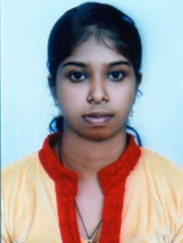I have completed Bachelor Degree in Medical Laboratory Technology and came to know that there is a vacancy in your organization and offer myself as a candidate for the same .If I get a chance to serve you I will assure you my full pledged efforts to the well being of the organization

ANJITHA S DAS

SIVASADANAM(H)

VELLOOR ,MEVELLOOR. KERALA-686609

CONTACT NUMBER: 9446843008 / 6361907585

**ACADMIC QUALIFICATION**

|  |  |  |  |
| --- | --- | --- | --- |
| COURSE | BOARD/UNIVERSITY | INSTITUTION | YEAR |
| Bsc(MLT) | RAJIV GANDHI UNIVERSITY KARNATAKA | CAUVERY COLLEGE OF ALLIED HEALTH SCIENCE | 2018 |
| V.H.S.C | KERALA STATE | G.V.H.S.S PERUVA | 2014 |
| SSLC | KERALA STATE BOARD | K.M.H.S, MEVELLOOR | 2012 |

**PERSONAL INFORMATION**

GENDER : FEMALE

AGE&DATE OF BIRTH : 25Yrs, 14/06/1996

NATIONALITY : INDIAN

MARITAL STATUS : SINGLE

FATHERS NAME : SIVADAS .P.K

MOTHERS NAME : AMBIKA .M.A

LANGUAGE KNOWN : ENGLISH,MALAYALAM,HINDI,KANNADA

**EXPERIENCE**

**CAUVERY HEART & MULTI SPECIALITY HOSPITAL MYSORE : 6 MONTHS EXPERIENCE**

**KUMAR HOSPITAL MYSORE : 1YEAR 11MONTH EXPERIENCE**

**DECLARATION**

I HEREBY DECLARE THAT ALLTHE ABOVE FURNISHED DETAILS ARE TRUE AND CORRECT TO THE BEST OF MY KNOLEDGE BELIEF.

MULAKKULAM YOURS SINCERERLY

DATE: ANJITHA S DAS