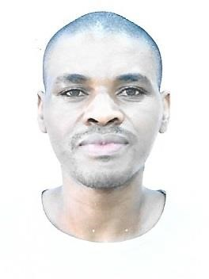**Curriculam-Vitae**

**ALEX KARAMUZI**

Mob: +971569793102

Email: Karamuzialex2@gmail.com

RAK - UAE

**OBJECTIVE:**

# Seeking a challenging opportunities where I can fully use my skills for the success of the Organization. Stimulating and challenging environment and will provide me with advancement opportunities

**PERSONAL SKILLS:**

* Strong ability to handle the work pressure
* **Hard working**
* **Excellent communication and reporting skills.**
* **Good analytic and problem-solving skills.**
* **Ability to multi-task, prioritize, and manage time effectively**
* **Ability to work under pressure even with limited supervision**

**EDUCATION DETAILES:**

# • Degree ( Bachelors of procurement and logistics management) from International University of east Africa

□ Nursing Assistant Certification from American Medical Certification Association conducted at strong point institute Dubai-UAE

**WORK EXPERIENCE:**

* **2 Years working experience as office clerk at Eclog international –Bagram AFGHANISTAN (May-2017 to May – 2019)**
* **1 Year working experience as a helper at SOS International LLC, Camp Taji – IRAQ (December2019 to August 2020)**
* **Working in Abudhabi Natioanl Hotels co as a Cleaner in Abu Dhabi- UAE (August 2021 to Still Now)**

|  |  |
| --- | --- |
| **LANGUAGES:** |  |
| o **English** |  |
| **PERSONAL DETAILS:** |  |
| ➢ **Date of Birth** | **: 03/12/1985** |
| ➢ **Nationality** | **: UGANDA** |
| ➢ **Gender** | **: Male** |
| ➢ **Marital Status** | **: Married** |
| ➢ **Visa Status** | **: Employment visa** |
| **PASSPORT DETAILS:** |  |
| ➢ **Passport no** | **: A00111466** |
| ➢ **Date of issue** | **: 12/07/2019** |
| ➢ **Date of Expiry** | **: 11/08/2029** |
| **DECLARATION:** |  |

**I hereby certify that the above information is true and correct to the best of my knowledge and belief.**

# ALEX KARAMUZI