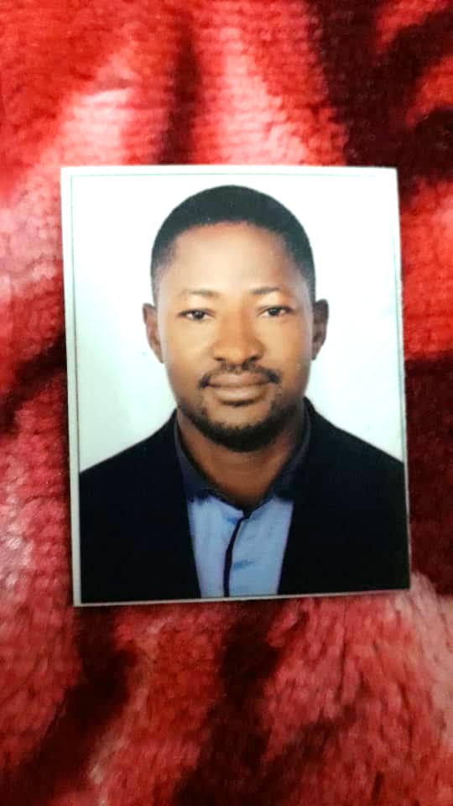**CURRICULUM VITAE (C V)**

**WILLIAM NANA OSEI-BOAKYE YIADOM**

**EMAIL**: **oseiboakyewilliam21@gmail.com**

**CONTACT**: **+971526844163**

**CARRIER OBJECTIVE**

I am a hardworking and self-motivated young professional who aims at pursuing and developing a long life career in the area of management, accounting, entrepreneur, finance and IT.

**EDUCATION AND QUALIFICATIONS**

**Academic Qualification Institute Year**

Bachelor of Commerce University of Cape Coast 2015-2017

Diploma in Commerce University of Cape Coast 2009-2012

Diploma in Computer Engineering Leso Computer Training Institute 2001-2002

Software Applications Leso Computer Training Institute 2001-2002

WAEC Saints John’s Secondary School 1997-1999

Basic Education Certificate Gyandu S.T.M.A. J.S.S. 1993-1996

Primary Education Chief Ibrahim Primary School 1984-1992

**WORK EXPERIENCE**

**AL ISHRAK CONTRACTING COMAPANY L.L.C. DUBAI - SECURITY**

**7TH NOVEMBER 2019 UP TO PRESENT**

* Checking sub-contractors attendances, time IN and time Out and total number of workers they bring on duty.
* Checking body temperatures of people coming in and out of the construction site.
* Inspecting delivery materials from supplies to the construction site tally with purchasing orders.
* Issuing transfer not on materials from site to another company site or stores
* Receiving visitors at site and taking their body temperature and personal details.
* Making sure car parks are in order

**NATIONAL SERVICE**

**CAPE COAST TEACHING HOSPITAL CAPE COAST GENERAL ACCOUNTS**

**SEPTEMBER-AUGUST 2017 -2018**

* Handeling accounts and finance activities at hospital
* Reconciliation of daily basis of accounts at hospital
* Scrutinizing and verifying vouchers / bills / documents / returns / payments / bank book / cash book / day book
* Raising of petty cash
* Keeping cash book up to date
* Cheques recording
* Ghana Integrated management information systems ( GIMIS)
* payment of allowance to doctors
* Issuing of payment Cheques to suppliers
* Raising of payment vouchers
* Receiving cash and issuing receipts
* Calculation of withholding Tax, Income Tax, Professional Allowance Tax, VAT,Goods and Service Tax etc.
* Sending Payment vouchers to audit for auditing

**PIMAG LIMITED**

**Operations Manager (hostel) CAPE COAST April 2004 up to date**

* Taking stocks of goods in the shop
* Managing day to day operations of the hostel
* Managing day to day activities of the mini market and Business center.
* Typing and printing of documents, photocopying, book binding, scanning, laminating,
* Prepaid vending, mobile money agent.
* Building supervisor
* Lease with suppliers of building materials and convey building materials to site
* Banking of sales revenue of various accounts of the company.
* Preparation of receipts and payment of hostel fees, business center and mini market
* Preparation of statement of financial position of the company and balance sheet
* Cash flow statements
* Bank reconciliation statements balances balance with the cash book
* Prepare staff SSNITcontributions and Tax deductions by the various employers are sent to tax office and SSNIT office to avoid penalty.
* Payment of cooperate tax
* Checking and receiving complaints from hostel tenants and solving the problems and faults encounter in the day to day operations of the hostel facilities.
* Supervisory role at the hostel annex in prampram, dwanyhe near Central University College.

**ANNCHELLE INTERNATIONAL SCHOOL TAKORADI**

**Teaching I. C. T. September –October 2003-2004**

* Tutored students in computer courses, graded tests and assignments
* Typing and printing of examination questions on termly basis
* Installation and setting up computer laboratory
* Servicing, repairing and maintance of the computers at the computer pool

**COUNCIL OF INTERNATIONAL PREPARTORY SCHOOL- SEKONDI**

**September –October 2003- 2004**

* Tutor students in computer courses, graded tests and assignments
* Typing and printing of examination questions on termly basis
* Installation and setting up computer laboratory
* Servicing, repairing and maintance of the computers at the computer pool

**OBIRI YEBOAH SENIOR SECONDARY SCHOOL- ASSIN FOSU CENTRAL REGION 2002-2003**

* Tutor students in computer courses, graded tests and assignments
* Typing and printing of examination questions on termly basis
* Installation and setting up computer laboratory
* Servicing, repairing and maintance of the computers at the computer pool

**BYCOM COMPUTERS KASO- CENTRAL REGION 2002 -2003**

* Teaching information communication technology of pupils from S.H.S 1 to S.H.S 3
* Typing and printing examination questions, repairing and servicing of computers.
* Building of computer laboratory at various schools

**AWARDS**

**FOOD AND DRUGS AUTHORITY GHANA**

CERTIFICATE OF PARTICIPATION IN GOOD MANUFACTURING PRACTICES (GMP) TRAINING IN FOOD PROCESSING

**ACHIVEMENTS**

* Expand the hostel facility from 11 rooms to 54 rooms at University of Cape Coast.
* Raise the revenue of the hostel from GHS 6,000.00 to 100,000.000 a year
* Been able to help in expanding and building a new 33 room’s hotel at Central University College at prampram with expected cash flow GHS 132,000.00 a year.
* Help in opening of pure water factory at the hostel and a laundry.

**SKILLS AND COMPETENCIES**

* Analytical thinking and uphold strong professional ethics in decision making
* Fluent in English Language
* Good at effective time management.
* A team player.
* Ability to work effectively with little or no supervision
* Excellent organisational skills
* Good Customer care
* Inter personal skills
* Communication skills
* Good sales skills
* Management accounts
* Forecasting, Planning Cost Accounting, and Budgeting
* Microsoft Word, Microsoft Excel, Microsoft Presentation and Tall Accounting etc.
* Quick learner of new software application

**HOBBIES**

* Reading
* Watching football
* Learning from the environment
* Computers and internet

**REFERENCES**

Mrs. Alberta Smith

Senior Accountant

Cape Coast Teaching Hospital Cape Coast, Central Region.

Tel: +233243-140930

University of Cape Coast, Central Region.

Tel: +23342-36946/35203

Fax: +23342-36946

E-mail: cceucc@yahoo.com

Mr. Stephen Nathan Kofi Piedu

C.E.O. Pimag Limited/Former Chief Inspector of Mines,

Mineral Commission Accra.

TEL: +233204-405426

Al Ishrak Contracting Company L.L.C Dubai

Telephone No. 04-3416841/3471724