CURRICULUM VITAE

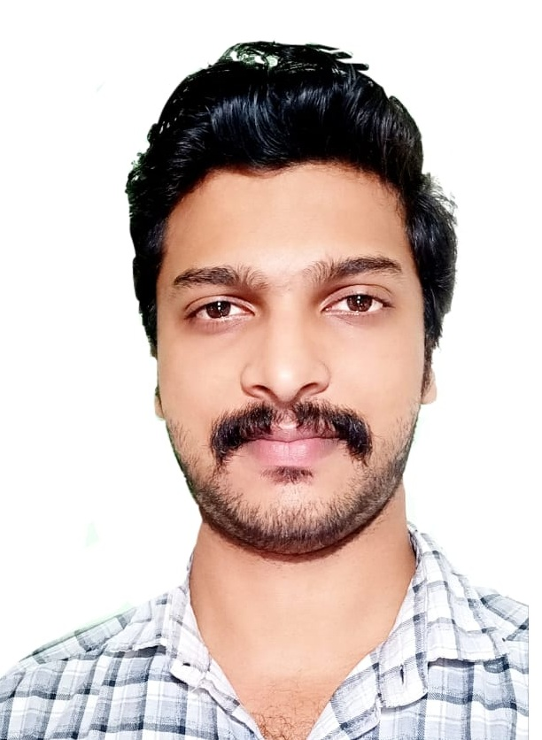
SUJESH P Email: sujeshp03@gmail.com
Mob: +919048142910

Personal Information:

Sex : Male
DOB : 03.03.1993
Nationality : Indian
Passport : P 1016665
 | read | speak | write
malayalam
English
hindi
tamil

Hobbies: Music, Drawing, Sports, Gaming

CAREER OBJECTIVE:

Looking for an entry into a world class, highly professional organization with challenging and competitive environment, where I can use my knowledge base as well as personal attributes to achieve the organizational goals.

ACADEMIC CREDENTIALS:
Bachelor Degree in Commerce
Bharathiar University, Kerala, India
Academic year 2013-2016
Higher Secondary Education
Kerala Board, India
Academic year 2008-2010
SSLC (Secondary School Leaving Certificate)
Kerala Board, India
Academic year 2008
AREAS OF EXPERTISE:

- Windows server 2008,2012,2012R2
- Installation, Configuration and Administration of AD, DNS, DHCP.
- Microsoft Office
- Technical Support
      - Networking
      - Remote support tools
      - Diagnosing hardware & network faults
      - Desktop Support

KEY SKILLS:

- Strong interpersonal skills
- Hard working
- Ability to manage multiple tasks and priorities
- Responsible
- Quick learner

PROFESSIONAL WORK EXPERIENCE

- AL-ATHARIYAH restaurant Riyadh, Saudi Arabia worked as an IT& Cost Controller (22/10/2019-10/07/2020)
- TEAM THAI Kozhikode worked as a SYSTEM ADMINISTRATOR (28.06.2017 - 08.08.2019
- Installing, configuring and supporting Microsoft Dynamics NAV.
- Configuring and troubleshooting MS Outlook and other E-mail Clients.
- Sophos firewall Support.
- Installing, configuring, managing, troubleshooting Microsoft operating systems, Supporting users and network administrators over the telephone and by email.
- Installing, configuring and managing printers and scanners.
- Install and maintain network hardware and software.
- Virus Diagnose & Remove Techniques
- 2X APPLICATION, Server Admin& Support
- CITRIX Server, Application Admin& Support
- Seqrite Central Antivirus Cloud Admin& Support
- HRMS & Biometric Sever Admin& Support
- ACCESS Control and EPBAX Tracking Server Admin& Support
- ARMS Server Admin & support
- TALLY Server Admin & Support
- FILE SERVER, PRINT Server Admin support
- Toner Refilling
- Cable installation, CCTV cameras installation, DVR configuration, access and support.
- Installed, repaired, and maintained CCTV cameras.
- Identified areas that required CCTV monitoring
- Software installation and application support.
- Smart IT Services PVT.LTD worked as TECHNICAL SUPPORT (06/10/2015 - 10/03/2017)
- Maksys Technology Services Pvt.ltd. Kozhikode worked as Associate Engineer(10.10.14 - 15.01.15)
- FINO Pay Tech Limited worked as Technical Support Executive. (RSBY) (08.05.2013 - 15.11.2013)
TECHNICAL SKILLS:

- Server Operating Systems: Microsoft Windows 2008 / 2012 R2.
- Client Operating System Windows: 7, 8, 8.1,10.
- Active Directory : Managing the Active Directory Services (Managing Users, groups, computers, Group policies), Configuration, Administration, Managing Domains, Trees, Forest, implementing OU, Administering User accounts, implementing group policy.
- Common services : Managing DHCP, DNS & Backup and Tap Management.
- Mail Clients : Ms-Outlook

IT CERTIFICATION:

- Microsoft Certified Technology Specialist: windows server® 2008 R2, Server Virtualization(MCTS)
- Computer Hardware (NCVT Certified)
- Computer Networking (NCVT Certified)
- Computer Fundamentals, MS-Office and Internet (NCVT Certified)
- CMS Certified Network Specialist (CCNS Certified)

Declaration:

I hereby declare that the above mentioned information is true and sincere to the best of my knowledge.
Place:
Date: SUJESH.P

