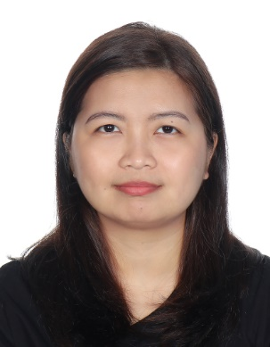**ROQUE, MARIA ANGELICA C.**

Fatima Bint Mubarak St., Abu Dhabi **●** +971 555142996

mariaangelicaroque@gmail.com

**Key Qualifications**

* Ten years of experience as Leader and Manager
* Excellent communicator
* Effective stakeholder and customer management skills
* Experienced in organizing workflow, ideas, materials, people

**Professional Experience**

**Manila Water Company, Inc.**

*Senior Territory Manager (January 2012 to December 2019)*

* Planned, controlled and monitored the daily business operations of the assigned territories
* Managed stakeholders and big accounts of the area on top of regular accounts; drafted correspondences as needed
* Handled customer complaints (face to face/calls/e-mails) and ensured that all transactions are within 100% SLA
* Processed project/customer documents and prepared reports as needed by HQ and/or presented to Top Management
* Training resource for new employees

*Territory Manager (July 2010 to December 2011)*

* Managed the technical, business and customer aspects of assigned territories
* Used customer segmentation in determining solutions for inquiries and complaints
* Verified log hours and overtime claims of handled employees

*Cadet Officer (January 2010 to June 2010; Cadet Trainee from June to December 2009)*

* Established, maintained, and managed business account relationships
* Planned, organized, monitored and managed resources of a project to achieve completion on schedule and attainment of targets at a minimum cost
* Used effective tools for data analysis and management

**Senate Electoral Tribunal**

*Head Revisor (November 2008 to May 2009)*

* Scrutinized the integrity of hard data taken from election paraphernalia during proceedings on electoral protests in the Senate of the Republic of the Philippines
* Supervised the smooth flow of the team's procedures and ensured that accomplishments are within standards

**Educational Background**

**University of the Philippines**

Master in Public Administration (2011 – 2016)

Bachelor of Arts in Philosophy (2004 – 2008)